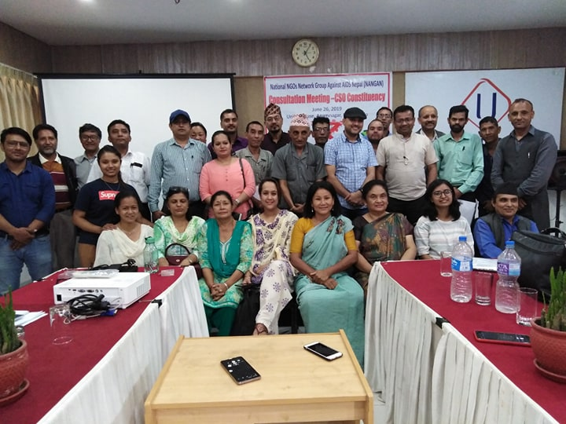**Consultation Meeting – CSO Constituency**

**Event Report**

**June 26, 2019 Union House, Anamnagar, Kathmandu**

**Submitted To**

APCASO, Thailand and CCM Nepal

**Submitted By:**

National NGOs Network Group Against AIDS Nepal (NANGAN**)**

Bijulibazar, Kathmandu, Nepal

Email: [nangan.network@gmail.com](mailto:nangan.network@gmail.com)

Web site: www.nangan.org.np

Contact number 01-4784249

**Introduction**

National NGOs Network against AIDS Nepal (NANGAN) is the umbrella organization of the NGOs working in the HIV sector. It has 120 member organizations all over the country working for the PLHAs, Key affected populations and general public. NANGAN represents the CSO Constituency in CCM from HIV sector consisting of 2 CCM member and their alternates. As per the CCM Nepal letter, NANGAN has decided to organize the consultation Meeting (two episode) for the effective constituency involvement and their strengthening and empowerment. For this, NANGAN in consultation with CSOs Constituency CCM members has planned to conduct the (two events) consultation meetings with its network members and Civil Society representatives before and after the CCM Meetings held in June and August 2019. In connection to this, the 1st event was organized on 26th June 2019 and this report highlights on the same.

**Preparatory Meeting with CCM Members and NANGAN Executive Committee**

NANGAN held a preparatory meeting with the CCM Members on 20 June, 2019 at its secretariat office, Bijulibazar. Discussing on this subject, the meeting decided to arrange the consultation meeting in June 26 and planned the agendas and participants accordingly. Likewise NANGAN Executive meeting held on 23 June, 2019 discussed and passed this program.

**Meeting Objectives**

The main objectives of these consultations (before meetings) are to bring the voices from the constituency through networks and share it to the CCM forum via CCM members.

The specific objectives are:

1. To collect and discuss issues gathered from the pre-consultation meeting held at Province level.
2. To collect issues from the consultation meeting participants and build common consensus among the others.
3. To document the consultations findings and compile/submit the report accordingly.

**Participants**

52 participants took part in this meeting including NANGAN members, Networks/Civil Society Organizations, Representatives working in HIV, TB and Malaria, INGOs and the other relevant stakeholders.

**Facilitators**

The key facilitators were: Mr. Dhirendra Lamsal and Ms. Indira Rana Magar, CCM Members and Ms.Anju K.C. Alternate CCM. member, Mr. Dal Bahadur G.C., President, NANGAN and Ms. Urmila Vaidya, NANGAN Executive Committee Members.

**Venue:**

The meeting was held at Union House, Anamnagar, Kathmandu

**Date and time:**

26 June, 2019, From 2.00 pm to 5 pm

**Consultation Meeting Agendas:**

1. Welcome and Objective highlight
2. NANGAN and its contribution in national response
3. Orientation about the CCM and its ROB
4. Update previous CCM decisions and Capacity building training at Gokarna
5. Province issues presentation and interaction
6. Way forward

**Proceeding of the Consultation Meeting**

**Welcome and objective Sharing**

At the beginning, Mr Dhirendra Lamsal, CCM Member welcome to the participants. He also shared the meeting objectives as mentioned above.

**Presentation by NANGAN**

NANGAN President Mr. Dal Bahadur G.C. presented about National Data about HIV prevalence as well as about NANGAN and its contribution in the national HIV policy and programs.

He firstly explained about the data of Nepal Estimates of HIV infections – 2016, then after he further explained the data of people living with HIV&AIDS in 2016. Lastly, he explained about the Estimates of Key Populations. These presentation were based on the facts sheet published by the National Center for AIDS and STD Control (NCASC) as below:



After presenting the data, Mr. Dal Bahadur G.C. presented about NANGAN and its contribution in the National response.

**NANGAN's Vision**

Society without AIDS

**NANGAN's Mission**

* To mitigate the transmission of HIV and ensure the dignified life for PLHAs by means of contributing to the effective implementation of the national HIV and AIDS strategy through advocacy and capacity building of the member organizations.

**NANGAN's Goal**

* Contribute effectively to the reduction of current HIV& AIDS prevalence rate in line with a new vision of ending the AIDS epidemic by 2030 and goals to achieve optimized Identify, Reach, Recommend, Test, Treat and Retain (IRRTTR) for 90-90-90 and combination prevention by 2020.

**NANGAN’s Objective**

**The objectives of NANGAN are to:**

1. Identify gaps and advocate for an effective policy at national/local level in order to ensure the rights of the PLWHA, Risk population including Migrants cross broader issues, SRHR and other vulnerable groups and support for implementing the program for addressing their issues effectively
2. Promote social protection and service integration in SRH, TB and Malaria sector and linked with livelihood and capacitate its member organizations through training and establishing effective network in all 7 provinces and support for regularize effective monitoring systems in 77 districts.
3. Establish a knowledge resources facility in the HIV/AIDS sector in smoothing and strengthening network, update profile and best practices information sharing and capacity building among member organizations and other stakeholders
4. Coordinate, collaborate and cooperate with GO/I/NGOs, civil society and private sectors working for HIV/AIDS, TB and Malaria preventing, control care and support by mainstreaming the development sector in HIV for its sustainable solution

**Recent works of NANGAN**

* Finalize NANGAN Strategy Plan for BS 2076 -2080
* Representing CCM from CSO Constituency
* Dissemination of the CCM Meeting 103rd Minute
* Supported for electing the CCM members from CSO Constituency
* Issue based interactions and lobbying in Migrant Labor Health issues
* Collecting issues from the provinces for advocacy and lobby to the effective response
* Developed concept notes on Cross boarder migrants and multi sectoral response in HIV&AIDS
* Supported nutritional foods and endowment fund for CABA
* Organized free Eye health camp at Kritipur
* Participating in various meeting and workshop for provide inputs or better Plan and policies

**NANGAN Possible Actions**

* Internetwork coordination Meeting for discussing the national gaps and its response
* Sensitization and Capacity building of the members and NGOs in context to country response and reaching to the unreached
* Orientation and Capacity building to the local bodies and stakeholders
* Psycho-socio Counseling training to the KAPs
* Collect gapping/lacking Information and share to the members and stakeholders from central to grass-root and vice-versa
* Sensitize, Advocacy and lobbying to the local bodies, provinces and federal level in HIV issues
* Assessments of Clients Satisfactions on services and collection and publications of the best practices

**Participants Feedbacks and Suggestions**

1. Better to present updated data of 2019
2. NANGANs area should not be far than the HIV&AIDS sector
3. Coordinate with the local bodies and Social Development Ministry, Health focused unit at Province level
4. District Coordination Committee and NAP+N can help to reach in the grass-root level

**Update about CCM and Capacity building trainings**

Mr. Sandesh Neupane, CCM Coordinator presented about the CCM Nepal history, Mandate of the CCM Nepal and the composition of CCM members.

In Nepal, CCM Nepal is working since 2002. It has provisioned 17 members representing 5 from Government, 3 from Community living with or affected by diseases, 3 from Key population, 2 from NGOs, 1 from Academia/Research Institute, 1 from Private sector and 2 from External Development Partners. The 3 year support money from Global Fund is 42 million USD. As per the new funding model, the period is 3 years and budget ceiling is provided earlier by the Global Fund. Due to some circumstances (Earthquake, Federal transaction and PRs disallowed expenses) Nepal is under the Safe Guarding Policy from 2015. Global Fund decided as a PR to Save the Children and the Government entity (NCASC, EDCD and NTC) and the SRs from the NGOs. Coordination will be maintained between donors for future funds. Minimum Standard service package is designed and PEFAR project is extending its resource 9.4 million USD per year. However, the Global Fund budget is planned to reduce and increase in the local level budget. However, it is difficult due to the confusion of Health plan in Federal structure.

**Participant’s queries and suggestions**

1. ROB and COI clarifications
2. How to meet 90:90:90 targets and minimize duplication
3. Transparency of the Oversight Committee findings
4. Not covered all districts by the program in some Provinces
5. Clarity for submitting the issues directly at CCM secretariat or through CCM meeting
6. PLHIVs issues should raise by others as well and should work combined
7. How the reagent issues can be tackled
8. Widening CCM role beyond the GF fund and oversight all the funding utilization

Mr. Sandesh Neupane, CCM Coordinator clarify about the participants queries and thank for their suggestions.

**Update of the Capacity Building training at Gokarna**

Ms. Indira Rana Magar, CCM Member presented about the outcomes of the Capacity Building Training at Gokarna on May 2019. Main learnings were: How to generate local level fund and how to available the services in the grass root level. She also highlighted about the circle of the capacity building, where CCM engagement and effective communication system may bring every one in the inner circle. She also shared the meeting of Regional CCM of South East Asia, where 18 country represents there and the meeting more focused to the women issues.

Ms. Urmila Vaidya, NANGAN Executive Committee member added that the Gokarna workshop was very useful to familiar about the CCM Member and constituency relationship as well as learned for speaking and dealing to the others.

**Gapping/lacking in HIV Response**

Ms. Anju K.C., NANGAN Vice-president and CCM Alternate member presented about the issues from the provinces.

**Province 1, Biratnagar**

* Low access in ART Services, In Morang there are only 336 cases in ART out of 1600 cases
* Negative impact on the PLHAs health due to not working the Viral Load machine and CD4 Count
* Lack of skilled manpower in PMTCT Services
* PLHIV are out of service due to the lack of equipment and skilled manpower
* PLHAs death cases are also due to the low access and treatment lacking
* The meeting decided to organize monthly sharing meeting with the NANGAN Coordination

**Province 3, Hetauda**

* Not having HIV related program with the HIV related organizations
* Delay or negligence due to the lack of CD4 Services and poor economic condition of the PLHIV
* Discontinue of ART by third gender due to the stigma and discrimination
* Not getting priority in HIV Program, due to the lack of knowledge to the local bodies
* Discontinuation in the ART due to the low understanding of PLHAs on its importance
* Opportunistic diseases is increased due to the lack of nutritious food
* Although PMTCT service is available here, the service is not taken due to the expensive package on it
* Should be strict referral mechanism while going to any general treatment
* Investment in IGP program is not yet success till date, due to the low trust for PLHIV

**Sudhur Paschim Province 7, Kailali**

* Kailali district is central place as well as the province center, thus there are many referral cases in Seti Zonal Hospital also many follow-up cases are there however the facilities for the clients is decreasing day by day
* Due to the clients visit in Kailali comes from various districts there were 2to 3 care centre and bed number was 8 but now there is lack of care centre and bed no is only 5
* Nutrition program is stopped, which were getting by the PLHIV before
* Lack of opportunistic diseases medicine for PLHAs and shortage of other medicines also especially in the pharmacy of Seti Zonal Hospital
* Lack of transportation expenses for the treatment of PLHIV
* In Kailali, there is no more Coordination, Networking and stakeholder meeting, which was held regularly before .
* Hence, this meeting recommends for the regular meeting and coordination among the stakeholders

**Feedbacks from the participants**

**Mr. Shyamkazi Shrestha, WATCH**

Meeting was very much fruitful, we can go further in a qualitative and meaningful way.

**Ms. Ashima Shrestha, Team Leader, FHI 360**

The provincial level issues are genuine, what we can recommend for the future

**Mr. Balkrishna Sedai, Nepal Red Cross Society (Ex. CCM Member representing Malaria)**

* There needs to modify the content i.e, About the CCM, specify the province level issues sharing and updating the National data
* There exists the communication gap between grass root level to CCM and CCM to grass root level
* In 18 years, CCM may have the maturity in Communication plan and Constituency engagement plan
* How to raise the new issues to the top level
* Civil Society should question to discontinue the Additional Safeguarding Policy

**Vote of thanks and closing**

Mr. Dal Bahadur G.C. NANGAN President remind the Consultation meeting achievement, which were: update national data and NANGAN efforts, Province level HIV&AIDS issues, Introducing CCM Nepal and its recent works for constituency engagement and capacity building. In the meantime participants get opportunities to ask their queries, interact as well as provide suggestion for the future betterment. NANGAN president thanked to all (especially the CCM members and CCM Coordinator Mr. Sandesh Neupane, Assistant Consultant Ms. Aney Rijal, National Networks representatives from 7 networks, Representatives from FHI 360 and AHF Nepal and Representative from District Coordination Committee) for their valuable participation and contribution to bring this event successful. Lastly, vote of thanks was provided to all the participants and the Consultation meeting was closed at 5:00 pm.

**Annex-1 - Meeting Schedule**

**Consultation Meeting- CSO Constituency**

**26 June, 2019, Wednesday (11 Ashad 2076)**

**Union House, Anamnagar**

**Meeting Schedule**

MC: Ms. Anju K.C., Vice President NANGAN, Alternative CCM Member

|  |  |  |  |
| --- | --- | --- | --- |
| **SN** | **Time** | **Activity** | **Responsible person** |
| 1 | 14:00 – 14:30 | Registration and High Tea  (Additional role for Logistics, note keeper and photography) | Ramesh Pandey, Treasurer and Durga Gurung, Office Assistant, NANGAN |
| 2 | 14:30 – 14:40 | Welcome and sharing meeting objectives | Dhirendra Lamsal, CCM Member |
| 3 | 14:40 -14:50 | Introduction | MC |
| 4 | 14:50 – 15:10 | Introducing NANGAN and efforts in supporting national policy and programs | Dal G.C., NANGAN President |
| 5 | 15.10- 15:30 | Introducing CCM and its Rules of Business | CCM Members and Secretariat |
| 7 | 15:30 – 15:45 | Update of last CCM Meeting and Capacity Building Workshop at Gokarna | Indira Rana, CCM Member and Urmila Vaidya, NANGAN EC Member |
| 8 | 15:46 – 16:15 | Presentation and Discussion on the issues from the provinces and consultation with the participants | Anju K.C. Vice President NANGAN, Alternative CCM Member |
| 9 | 16:15 – 16:30 | Speeches from the Guests and Participants | CCM Nepal, Network Rep, Participants, NCASC |
| 10 | 16:30 -16:45 | Way forward | Existing CCM Members |
| 11 | 16:45 -16:50 | Vote of thanks | Dal G.C., NANGAN President |
| 12 | 16:50 onwards | Tea and Cookies |  |

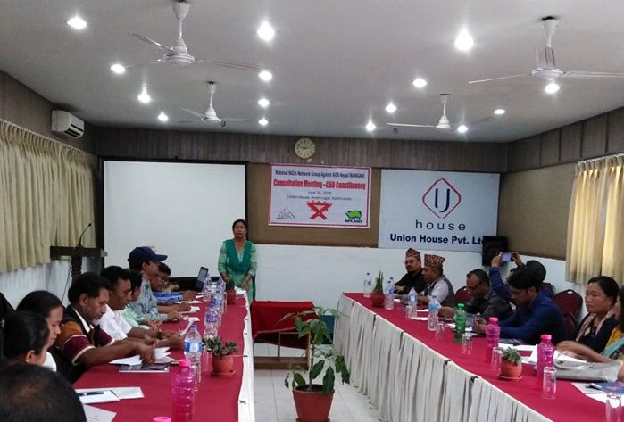**Annex -2 Event at a Glance**

