

**FUNDING REQUEST APPLICATION FORM**

**Full Review**

|  |  |  |  |
| --- | --- | --- | --- |
| **SUMMARY INFORMATION** | | | |
| **Applicant** | Nepal | | |
| **Component(s)** | Malaria | | |
| **Principal Recipient(s)** | Save the Children Federation Inc. | | |
| **Envisioned grant(s) start date** | 16 March 2018 | **Envisioned grant(s) end date** | 15March 2021 |
| **Allocation funding request** | US$ 4,208,547 | **Prioritized above allocation request** | US$ 2,433,633 |

|  |
| --- |
| ***IMPORTANT:***  **To complete this funding request**, please:   * Refer to the accompanying***Funding Request Instructions: Full Review****;* * Refer to the Information Note for each component as relevant to the funding request, and other guidance available, found on the [Global Fund website](http://www.theglobalfund.org/en/applying/funding/resources/). * Ensure that all mandatory attachments have been completed and attached. To assist with this, an application checklist is provided in the Annex of the*Instructions*; * Ensure consistency across documentation.   **Applicants are encouraged to submit a joint funding request** for eligible disease components and resilient and sustainable systems for health (RSSH).  **Joint TB/HIV submissions are compulsory for a selected number of countries with highest rates of co-infection.** See the related [guidance](http://www.theglobalfund.org/en/applying/funding/resources/#coreinformationnotes) for more information. |

**This funding request includes the following sections:**

**Section 1**: Context related to the funding request

**Section 2**: Program elements proposed for Global Fund support, including rationale

**Section 3**: Planned implementation arrangements and risk mitigation measures

**Section 4**: Funding landscape, co-financing and sustainability

**Section 5**: Prioritized above allocation request

|  |
| --- |
| **SECTION 1: CONTEXT** |
| This section shouldcapture in a concise way relevant information on the country context.Attach and refer to key contextual documentation justifying the choice of interventions proposed. To respond, refer to additional guidance provided in the*Instructions*. |

|  |  |  |  |  |
| --- | --- | --- | --- | --- |
| **1.1 Key reference documents on country context** | | | | |
| List contextual documentation for key areas in the table provided below. If key information for effective programming is not available, specify this in the table (“N/A”) and explain in Section 1.2how this was dealt with within the context of the request,including plans, if any, to address such gaps.  Applicant response in table below. | | | | |
| **Key area** | **Applicable reference document(s)** | **Relevant section(s)& pages nb.** | **N/A** | |
| **Resilient and Sustainable Systems for Health (RSSH)** | | | | |
| Health system overview | Annex 1. Annual Report, Department of Health Services, 2015-16, Ministry of Health, Government of Nepal. [http://dohs.gov.np/wp-content/uploads/2017/06/DoHS_Annual_Report_2072_73.pdf] | XXIII-XXVI | ☐ | |
| Health system strategy | Annex 2. Nepal Health Sector Strategy, 2015-20. Ministry of Health and Population, Government of Nepal, 2015.  Annex 1. Annual Report, Department of Health Services, 2015-16, Ministry of Health, Government of Nepal. [http://dohs.gov.np/wp-content/uploads/2017/06/DoHS_Annual_Report_2072_73.pdf] | All  XXVII-XXXVIII | ☐ | |
| Human rights and gender considerations (cross-cutting) | Annex 3. Health Sector Gender Equality and Social Inclusion Strategy, Ministry of Health and Population, Government of Nepal, 2009. | Pages 1-2& 12-18. | ☐ | |
| **Disease-specific** | | | | |
| Epidemiological profile (including interventions for key and vulnerable populations, as relevant) | Annex 4. Operational Framework for Malaria Elimination in Nepal, July 2017. Epidemiology and Diseases Control Division, Department of Health Services,  Ministry of Health  Annex 5. Formative Assessment to CharacterizeImported Malaria and Identify Strategies for Accessing High-Risk Mobile and Migrant Populations in Nepal (2017) UCSF Global Health Group Malaria Elimination Initiative, Ministry of Health, Tribhuvan University and Kantipur College of Medical Sciences. | Pages 7-11  All | ☐ | |
| Disease strategy (including interventions for key and vulnerable populations, as relevant) | Annex 6. National Malaria Strategic Plan 2014-25 (NMSP),  Annex 7. ‘Addendum to the NMSP, 2017’.  ‘Operational Framework for Malaria Elimination in Nepal, July 2017’. | All  All  Pages 17-43 | ☐ | |
| Operational plan, including budgetary framework | Annex 4. ‘Operational Framework for Malaria Elimination in Nepal, July 2017’.  NMEP Budget. | All  All | ☐ | |
| Program reviews and/or evaluations | Annex 8. ‘Malaria Programme Review in Nepal, 1-9 June 2017’. | All | ☐ | |
| Human rights and gender considerations (disease-specific) | Annex 9. ‘Chhaupadi’ https://en.wikipedia.org/wiki/Chhaupadi | 1 page | ☐ | |
| *Add rows as relevant, for any additional key area as relevant to the funding request* | | | | |

|  |
| --- |
| **1.2 Summary of country context** |
| To complement the reference documents listed in Section 1.1 above, provide a summary of the critical elements within the context that informed the development of the funding request. The brief description of the context should cover disease-specific and RSSH components, as appropriate, as well as human rights and gender-related considerations.  **(maximum 2 pages per component)** |

**Overview of health system.**Nepal has a comprehensive health infrastructure stretching to Ward level. The four-tier health services delivery system follows a decentralized administrative approach. Disease control programmes are implemented through Regional Health Directorates, with District-level the main focus for implementing malaria control activities. Government of Nepal (GoN)– Epidemiology and Disease Control Division (EDCD) is responsible for providing preventive and curative services to the population at risk (annex 6). The role of the Private Sector (PS) in malaria case management is important[1], but ill defined, and PS engagement is a pre-requisite for elimination. Community-based services for malaria are currently restricted to referral by Female Community Health Volunteers (FCHVs) based on clinical symptoms.

**Health System Strategy.**The current Nepal Health Sector Programme, outlined in the ‘Nepal Health Sector Strategy, 2015-20’ (NHSS), provides a roadmap towards universal coverage of basic health services as enshrined in the Constitution of Nepal 2015. It calls for a substantive change in the way the sector is organized and managed, consistent with the Sustainable Development Goals (SDGs).

The NMSPis aligned with the NHSS, but was out of step with the latest guidance on elimination from WHO (published 2017). This has been addressed through the development of an ‘Addendum’ (annex 7) and an ‘Operational Framework’ (annex 4) upon which this application is based.

**Overview of malaria situation****.** The overall malaria trend during the last 10 years clearly indicates that substantial progress has been made towards elimination in Nepal (Figure 1.2.1). Financial support from GFATM has been critical.

With the exception of upsurges in 1991 and 2002-3 the malaria burden in Nepal has declined steadily since 1985 (when more than 42,000 cases were confirmed). Just 1,009 confirmed cases were reported in 2016 and 502 (50%) of these were classified as imported[2].84% of cases were caused by *P. vivax* and 16% by *P. falciparum* (figure 1.2.1). All Districts now have an API<1/1,000 and the country is moving towards elimination.

**Figure 1.2.1. Annual number of officially reported confirmed malaria cases in Nepal since 2004 (by species and origin since 2010) and total slides examined (TSE).**

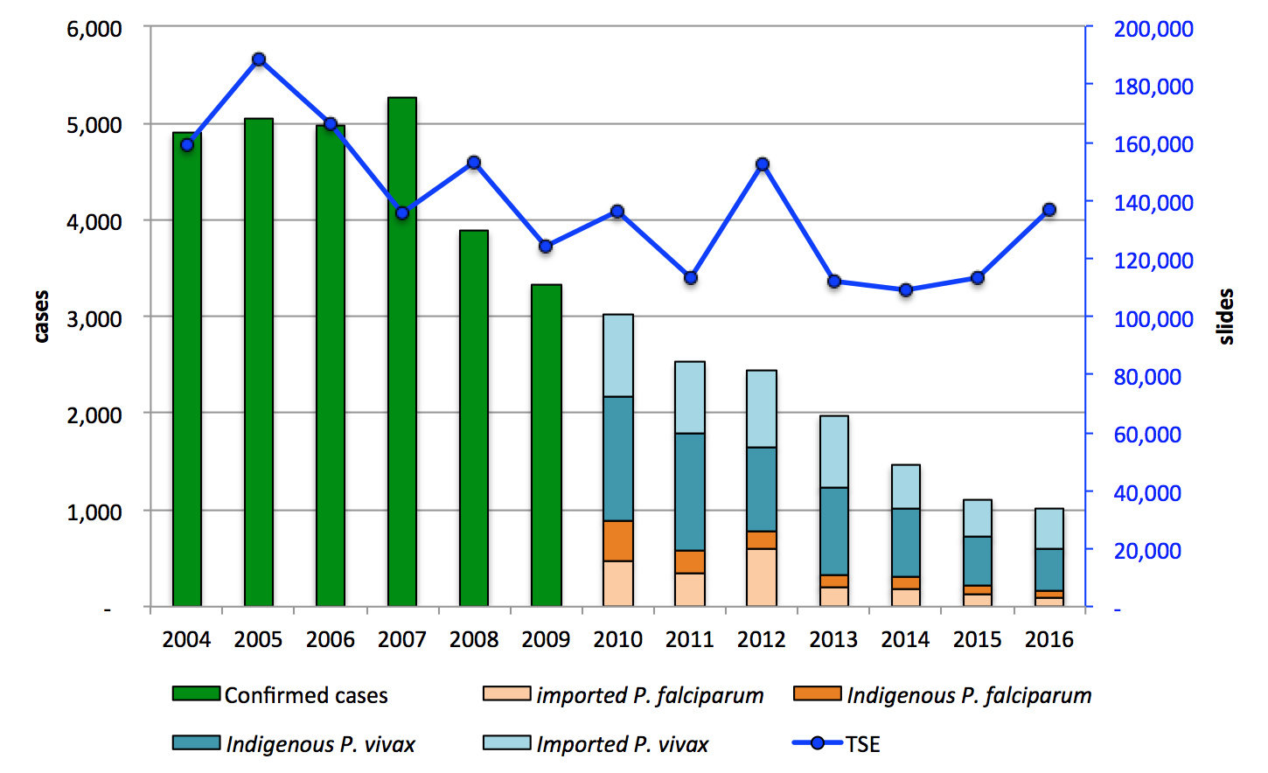

Malaria risk maps for Nepal are presented in Figures1.2.2.a (2013 stratification, which gives an overview of risk and an impression of receptivity) and b (presence of indigenous cases during 2014-16). 27 and 38 of Nepal’s 75 Districts are endemic and receptive respectively. During non-epidemic years most indigenous cases occur in the wooded foothills along the northern edge of the ‘Terai’[3] (the ‘Inner Terai’). During epidemic years outbreaks may occur in the ‘Outer Terai’[4], closer to the border with India.

Malaria cases occur throughout the year. Reported incidence is lowest in December-February, starts to increase in March, but rises markedly following the arrival of the monsoon in May. The majority of cases are reported between June and September.

**Figure 1.2.2.a. Micro-stratification of malaria risk by VDC, 2013.**

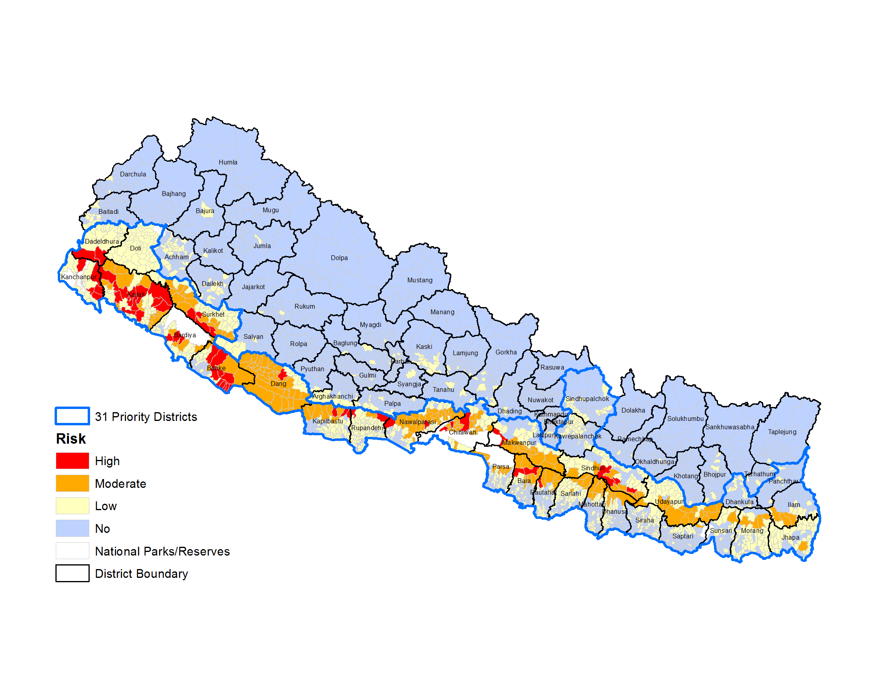

**Figure 1.2.2.b. Indigenous cases during 2014-16.**

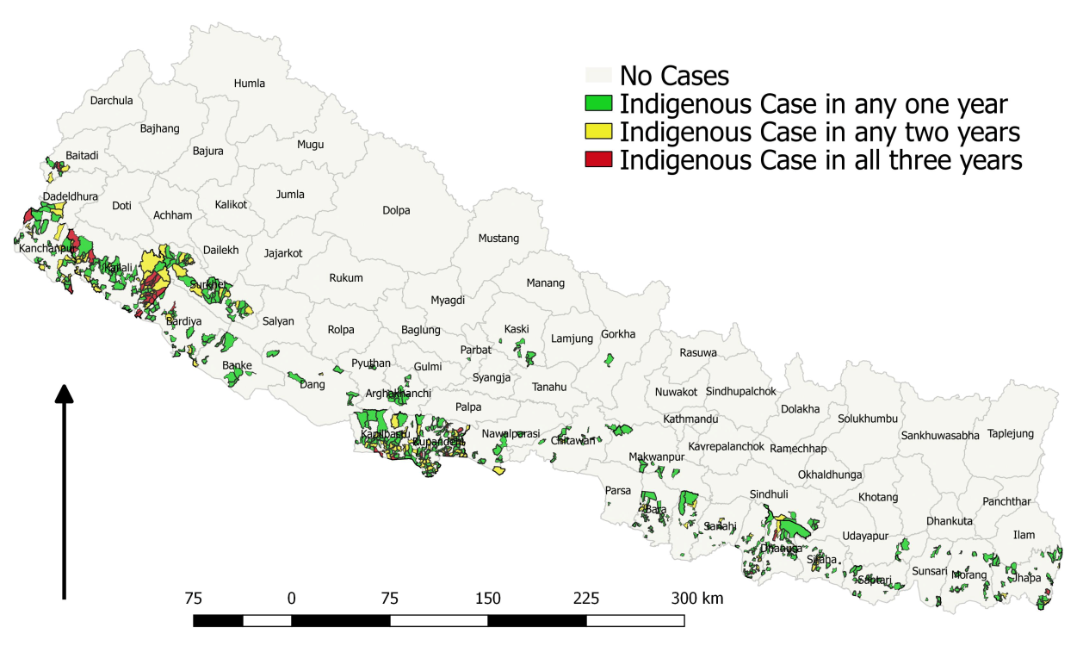

*Source:* EDCD

**Populations at risk****.**  An analysis of the relative incidence in 2016 of indigenous cases by age and sex revealed higher incidence in adults than in children and incidence in men double that in women (figure 1.2.3). In endemic areas of Nepal, occupational exposure is an important factor for adults,especially men. Forest workers, miners, woodcutters, charcoal makers or roaming livestock farmers are at greatest risk. Only 3/27 endemicDistricts exhibited age-sex incidence patterns clearly indicative of community-based transmission (high incidence amongst children) (see Operational framework – Annex 4, p11).

**Figure 1.2.3. Relative incidence of indigenous malaria by age-group and sex.**

With ~50% of cases imported by migrants returning from India, often to receptive areas,the risk of reintroduction in malaria-free Districtsis a major concern. Instances of reintroduction are common and have been well documented (Annex 10). Providing targeted services for thesemigrants[5]will be key to accelerating elimination and preventing reintroduction.

**Box 1.2. Nepalese migrants in India.** The vast majority of migrants to India travel long distances, basing themselves in Southern, Central and North-Eastern States (the latter border with Myanmar where multi-drug resistance is an issue). States that border with Nepal are of little of no significance in terms of malaria importation. Many migrants to India work in major cities where living conditions are often cramped. In these urban areas malaria transmission is maintained by *An. stephensi*. These populations often have limited access to prevention, diagnostic testing, and treatment services. Many work nights outdoors as guards, miners, cement, brick, diamond and garment factory workers etc. and so occupational exposure is common. Effectiveness of LLINs in these circumstances may be somewhat limited, but even so their deployment is still likely to be worthwhile given that the alternatives are limited.

Many Nepalese migrants in India group together to form communities and some members of these communities are particularly well networked. The Programme will work with these ‘networked individuals’ to develop and pilot new strategies for malaria prevention and case management for migrants, including targeted provision of preventive and case management services, e.g. through migrant malaria volunteers equipped with RDTs and antimalarials. Work will be carried out in collaboration with Indian counterparts with facilitation by WHO-SEARO and country offices.

**Main constraints.**The malaria surveillance system requires very significant strengthening to bring it in-line with the requirements of elimination. Annual blood examination rate in endemic and receptive Districts will need to increase from less than 1% to between 5 and 10% to support certification of malaria elimination. The absence of community-based services, the limited level of PS engagement and the lack of services for migrants are critically undermining progress towards elimination.

**Opportunities for service delivery**. FCHVs/Auxiliary Health Workers (AHWs)/Auxiliary Nurse-Midwives (ANMs)are well placed to support the rapid roll-out of community-based ‘test, treat, track’. Engaging with the PSand rolling out community-based services will likely double the case detection capacity of the Programme.The Programme’s better understanding of malaria in migrants will support the piloting of better-targeted interventions.

**Human rights and gender.**The impact of human rights issues on access to malaria services has diminished very significantly since the ‘Comprehensive Peace Agreement of 2006’. GoN and the Programme have embraced ‘Universal Coverage’ and the SDGs. Obstacles to access are now related primarily to the mobility of some members of the target population. Gender related issues do however still present access problems in some Hindu communities in Nepal where men view menstruating and post-partum women as untouchable. Inmany remote parts of the Inner Teraimenstruating/post-partum women are forced to sleep in huts away from the family home, a practice known as ‘chhaupadi’. The rudimentary construction of these hutsputs these women at increased risk of malaria. Legislation criminalising‘chhaupadi’ has recently been introduced with penalties including imprisonment. However, enforcement is likely to be problematic and so the Programme will continue to provide additional LLINs to ensure that women can be protected at all times. Where IRS is implemented this will also target chhaupadihuts.

There are still ~18,000 Bhutanese refugees living in 2 camps in an endemic area of Jhapa District[6]. In 2018 they will be provided with LLINs and the NGO healthcare provider based in the camp will be trained and equipped with RDTs and antimalarials (as part of the PS initiative).

The vast majority of community-based services are implemented through FCHVs and ANMs and so are inherently gender sensitive. Efforts will be made to ensure synergies with other health services where feasible (e.g. the roll-out of community- based services will be integrated into routine service provision by the Child Health Division).

**Role of communities in Programme design**.Extensive community consultations were conducted by EDCD prior to the development of this funding request[7]. Focus group discussions were conducted in 5 Districts (Jhapa, Dhanusa, Bardiya, Chitwan and Kanchanpur) and Regional consultations were held in 4 Regions (Banke, Chitwan, Kailali and Morang) and a National consultation was conducted at Central level.

**Key information gaps.**Malaria in migrants has only been studied in 3 far western Districts. Migrant mapping for malaria will be rolled-out to other endemic/receptive Districts as soon as possible.

The role of the PS is poorly understood. PS mapping will be conducted in 2017/2018.

**Normative guidance.** The ‘Operational Framework’ on which this application is based is in-line with the latest normative guidance on malaria elimination.EDCD/SCI/WHO are currently preparing related policy documents and SOPs.

|  |
| --- |
| **1.3 Past implementation and lessons-learned from Global Fund and other donor investments** |
| 1. List recent disease-specific Global Fund grants from the 2014-16allocation period and summarize key lessons learned from their implementation. 2. Include lessons-learned from specific HSS grants or any HSS investments embedded in the disease-specific grant(s) from the 2014-16 allocation period as applicable. 3. Outline lessons learned from investments by other donors as applicable.   For each of the above, explain how these lessons learned are taken into account in this funding request.  **(maximum 1 page per component)** |

***a). List recent disease-specific Global Fund grants from the 2014-16 allocation period and summarize key lessons learned from their implementation.***

**Table 1.3. GFATM grants for malaria in Nepal during the 2014-16 allocation period.**

|  |  |  |  |  |  |
| --- | --- | --- | --- | --- | --- |
| No. | Grant type | Grant amount *US$M* | Period | Grant code | Principal recipient |
| 1 | SSF | 3.3 | 16 Jul 2014 - 15 Jul 2015 | NPL-M-EDCD | Ministry of Health |
| 2 | SSF | 2.9 | 16 Jul 2015 - 15 Jul 2016 | NPL-M-SCF | Save the Children Federation Inc[8]. |
| 3 | SSF costed extension | 9.3 | 16 Jul 2016 - 15 Mar 2018 | NPL-M-SCF | Save the Children Federation Inc. |

Very significant improvements in grant management and implementation took place following the appointment of SCI as PR[9]. SCI will therefore continue as PR, working alongside EDCD to improve its technical and management capacity.

Poor data quality, due to a combination of limited technical capacity, overly burdensome reporting (for malaria and other diseases), and multiple reporting channels, has hampered technical management of the Programme. Although there have been very significant improvements under the current grant, effective targeting of LLINs for example remains a laborious process. Robust plans are now in place to have a state-of-the-art elimination-ready surveillance system in place, fully functional and quality assured by the end of 2019.

Malaria education programmes targeting schools, healthcare providers (public and PS), FCHVs and mothers‘ groupshave demonstrated the effectiveness of the ToT and trickle-down training approach. The same approach will be adopted for reorientation of healthworkers and volunteers and for target group specific training for armed forces, migrant workers, etc.

Implementation has been undermined in some areas by an ageing and overburdened workforce (VCIs and MIs are responsible for 12 different vector borne diseases and some are not computer or even SMS literate and struggle with data compilation and reporting). DPHOs will be encouraged to develop a second-line team ofyoung VCIs (recruited largely from existing staff) who can carry-out surveillance and other key technology-dependent activities.

Guidelines and major documents have not all been printed and disseminated as needed, and this has undermined the coherency of the Programme and resulted in confusion regarding roles and responsibilities of staff in the new elimination setting. Proper dissemination will be prioritised under the new grant in support of Programme reorientation efforts.

The functionality of the TWG has been sub-optimal to date. This will be addressed through the development of ToRs, the introduction of regular as well as *ad hoc* meetings and the recruitment of new and active members to reinvigorate the group.

***b). Include lessons-learned from specific HSS grants or any HSS investments embedded in the disease-specific grant(s) from the 2014-16 allocation period as applicable***

Human resource capacity development has been adversely affected by the constant transfer of key personnel at all levels[10]. New personnel need time to adjust and understand the disease, the Programme and their responsibilities. EDCD will lobby MoH to minimize the number of staff transfers but some transfers will be unavoidable and so on-going training on GFATM related requirements will be needed.

As identified in the recent MPR, there is a critical lack of entomological support for the Programme. Efforts are now underway to strengthen the entomological component through training. Further training is planned under the new grant.

Medicine and health commodities waste management has been a chronic challenge in Nepal and piles of unusable stocks at Districtwarehouses and peripheral stores now unnecessarily occupy limited storage space. This matter is now being addressed[11]. In future the newly established logistics management information system (LMIS),improved quantification of drug and commodity requirements and effective stock rotation should minimize expiries.

**c). Outline lessons learned from investments by other donors as applicable.**

Bill and Melinda Gates Foundation(~US$150,000 annually): A study of migration in relation to malaria in 3 far western Districts has revealed a wealth on information, which will be used to improve the targeting of interventions for this key risk group (see ‘Population at risk’ in section 1.2).

United States Agency for International Development/President’s Malaria Initiative (US$150,000 annually): The long-term TA embedded at EDCD has beenkey to buildingEDCD/PR capacity and should continue.

|  |
| --- |
| **SECTION 2: FUNDING REQUEST (Within Allocation)** |
| This section should describeand provide a rationale for the program elements proposed for this funding request.Attach and refer to completed**Programmatic Gap Table(s), Funding Landscape Table(s), Performance Framework and Budget**, and refer to national strategy documents as applicable.  To respond, refer toadditionalguidance provided in the*Instructions.*  Ensure that the funding request as described in questions 2.1 and/or 2.2 meets the focus of application requirement as outlined in section 2.3. |

|  |
| --- |
| **2.1 Disease-specific funding request**  *Not applicable if the application is a standaloneRSSH request.* |
| Given the context and lessons learned outlined in Section 1,   1. Describe the disease-specific funding request(s), the rationale for prioritizing modules and interventions, and how these choices ensure the highest possible impact with a view to ending the three diseases and removing human rights and gender-related barriers to accessing services.   For any priority modules for which gaps are difficult to quantify in the programmatic gap tables, explain here the barriers being addressed, the proposed interventions and the population or groups involved.   1. Explain how the funding request addresses the key funding gaps reflected in the Funding Landscape Table(s) for the disease program(s) in the current allocation cycle, and specify other actions planned to cover remaining gaps.   For funding requests including both HIV and TB components:   1. Describe the coordination of joint TB and HIV strategies, policies and interventions at different levels of the health system, including community systems, and expected impact and efficiencies from the joint programming.   Ensure the answer appropriately reflects the separate disease programs in addition to cross cutting modules where appropriate.  **(maximum 4pages per component)** |

a). Some of the activities identified for ‘within allocation’ support are a continuation of high impact activities supported under the current GFATM grant. Others are innovations to address the issues undermining progress towards programmatic goals described in section 1,and to support the move towards elimination.

A detailed prioritization was carried out at the sub-activity level[12].

**Module 1. Case management.**

The detection of malaria infections will be based primarily on blood examination by RDTs or microscopy. The Programme aims to test all fever cases in endemic Districts and all symptomatic cases with an indicative travel history in non-endemic Districts. The ABER will be increased from below 1% (2016) to at least 5% by 2020. This increase will be made possible through the roll-out of community-based testing, the temporary expansion of Mobile Malaria Clinics (MMCs) and through PS engagement. This increase is in-line with the increased case detection requirements associated with elimination.

**Table 2.1. Breakdown of ‘within allocation’ costs by module and intervention.**

|  |  |  |  |
| --- | --- | --- | --- |
| **Module** | **Intervention** | **Within allocation** | **% of within allocation** |
| Case management | Facility-based treatment | 365,778 | 8.69% |
|  | Integrated community case management (ICCM) | 52,227 | 1.24% |
|  | Active case detection and investigation (elimination phase) | 351,594 | 8.35% |
|  | Severe malaria | 51,219 | 1.22% |
|  | Private sector case management | 115,111 | 2.74% |
|  | IEC/BCC | 14,418 | 0.34% |
|  | Other case management intervention(s) | 254,765 | 6.05% |
| Health information systems and M&E | Routine reporting | 217,881 | 5.18% |
| Analysis, review and transparency | 30,869 | 0.73% |
| Program management | Policy, planning, coordination and management of national disease control programs | 2,097,727 | 49.84% |
| Grant management | 307,919 | 7.32% |
| Other program management intervention(s) | 8,520 | 0.20% |
| Vector control | Long-lasting insecticidal nets (LLIN) - Mass campaign | 166,409 | 3.95% |
|  | Long-lasting insecticidal nets (LLIN) - Continuous distribution | 83,244 | 1.98% |
|  | Entomological monitoring | 41,634 | 0.99% |
|  | Other vector control measure(s) | 49,232 | 1.17% |
| **Total** |  | 4,208,547 | 100.00% |

Treatment will be in-line with WHO guidelines and will include primaquine. Where possible, supervised treatment will be used to support patient adherence to radical treatment. This will entail incentivised follow-up visits by patients to health facilities both for tracking compliance and for drug efficacy monitoring. Patients’ adherence will be maximized throughinter-personal communication by healthcare providers. The importance of this ‘adherence advocacy’ will be emphasized in all clinical training sessions.

The Programme will maximize coverage through public, community-based and private channels while making efforts to improve quality. Community based diagnostic and treatment services will be introduced in endemic areas through the existing FCHV/AHW/ANM networks. Registered PS providers will be required to test and treat patients according to the NMTP. Both will be expected to provide G6PD testing and primaquine treatment as appropriate. RDTs, G6PD tests and antimalarials will be provided by the programme. All providers will be required to enter details of all positive cases into the MDIS by SMS (or inform the DPHO by phone) within 24 hours of diagnosis. Treatment by unregistered PS providers will be strictly prohibited and enforced through the joint actions of the local administration and local public health authorities.Supply and supervision of PS providers will be the responsibility of DPHO focal points (the Programme will be responsible for sensitization and oversight will be provided jointly by DPHOs and SCI provincial staff).

Robust supervision is key to QA of patient care, and will be applied for both public and PS with clear protocols.

*Facility-based treatment*.Requested funds will cover:Annual supply ofthe consumables required for microscopy and the procurement, supply and maintenance of essential laboratory equipment; A workshop to improve internal QA/QC of malaria microscopy (Y2);Regular supervision visits of lab personal from central to district level; Establishing a microscopy quality database at central level (Y1); Conducting annual external malaria microscopy competency assessments; Training of trainers on treatment guidelines including management of severe malaria (Y1&3); Training and refresher training of medical doctors on treatment guidelines including management of severe malaria (Y1);Temporarily Intensified case detection by 8 MMC teams covering 7 higher burden Districts (pending roll-out of community based services) (Y1&2); Clinical reviews of death cases by central and district level staff (field visits) (Y1-3); and,the procurement of RDTs and antimalarials (see programmatic gap table).

*Community-based treatment*.During 2018 the Programme will introduce community-based RDT testing,G6PD testing and treatment by FCHVs/AHWs/ANMs; Requested funds will cover:Training for at least 6,692FCHVs/AHW/ANMin 550 endemic VDCs identified during the 2017 stratification; and, the procurement of RDTs and antimalarials (see programmatic gap table) in 54 Wards. GoN will support monitoring by supervisors who will provide additional on-the-job training as required.

*Private sector case management.*During 2018-20 the Programme will roll-out its PS engagement strategy. Requested funds will cover: Orientation on elimination and training on the NMTP for 270PS healthcare providers in 27 Districts; Annual *per diem* and travel costs for the DPHO focal person to engage with PS providers (administered by SCI); Training of private sector medical doctors on treatment guidelines including management of severe malaria; *Ad hoc* supervision of non-compliant PS healthcare providers through DPHO, EDCD and DDA; and, Procurement of RDTs and antimalarials (see programmatic gap table).

*Active case detection and investigation*. The timeliness of the response to confirmed foci is key to effective control. Nepal will adopt a ‘1-3-7 approach, whereby: cases must be notified on the day of detection; case investigation must be conducted within three days of detection; and investigation of suspected foci and response actions must be implemented within seven days of detection. Performance will be monitored against this 1-3-7 benchmark.

If a confirmed case is detected, the service provider will immediately submit a ‘case notification report' to MDIS via SMS. If they are unable to do so they will immediately inform their DPHO malaria focal point by phone, and the focal point will enter the details themselves to ensure every case is MDIS registered in a timely way.

Public sector facility staff in endemic/receptive districts will be trained to review and assess every malaria case identified to the MDIS using detailed case investigation forms (currently under revision). The resulting ‘case investigation reports’, covering travel history, ecological factors, recent epidemiological data and an assessment of likely site of transmission, will be submittedto DPHO malaria focal points within 3 days of case detection.

Prompt investigations will be carried out in response to any suspected transmission foci. The investigations will be centred on the suspected site of transmission (home and/or workplace). A team of health staff from District and health facility level will complete an investigation within 7 days of the original case detection. The investigation will include ecological and entomological assessments, group discussions and interviews and active case detection (ACD). The scale of the ACD will be tailored to fit the local situation (based on SOPs). Volunteers will assist as necessary. The investigation team will submit an investigation report to DPHO and Regional/Central level within 24 hours of completing their one-day investigation. The report findings will be entered into the MDIS.

The investigation report will be reviewed by the DPHO in consultation with Regional/Central staff and if a focus/outbreak is confirmed, its intensity and likely scale will be assessed and an emergency plan will be developed based on SOPs. The scale of the response will be tailored to suit each specific situation. DPHO focus response teams and District RRTs will be responsible for implementing the response to foci and outbreaks respectively. Within 7 days of original case detection ACD will be instigated in the surrounding area and, depending on the findings of the entomological and ecological assessments, either focal responsive IRS will be applied or LLINs will be given to those in need. ACD visits will continue monthly/quarterly until caseload falls to zero and the focus is cleared.

To date, the reorientation of staff, to put them on an elimination footing rather than a control footing, has only been carried-out for workers at district level in 25/75 Districts (but this training needs to be updated based on the Operational Framework). It is imperative that all staff receive this critical reorientation as soon as possible. This will be addressed as a priority in 2017 but continued reorientation will be needed in 2018 (GoN funded).

Requested funds will cover: TA to strengthensurveillance activities (Y1-3); Capacity-building training for field staff and volunteers on case detection, case investigation, transmission focus investigation and transmission focus response system to Health Post level in 38 districts and to DPHO level in 10 Districts[13](ToT & multipliers)*;* Case investigations (costs for field visits – 807in Y1 (85% of 1,009), 783 in Y2 (95% of 824) and 667 in Y3 (100% of cases)); Travel cost for follow-up to confirm treatment compliance (costs for field visits – 807 in Y1, 783 in Y2 and 667 in Y3); Focus investigations (costs for field visits – 127in Y1 (80% of 158 foci), 120 in Y2 (100% of foci) and 85 in Y3 (100% of foci) – including the entomological component of focus investigations and operational costs associated with responsive IRS in active foci (costed under the ‘Vector control’ module); and, procurement of equipment for Rapid Response Teams.

*IEC/BCC:* The Programme in collaboration with NHEICC and WHO will develop and produce target-group-specific and locally appropriate BCC materials[14] and methodologies for all high-risk groups, as well as for communities approaching elimination. The approach and key messages[15]will be tailored to the specific requirements of the target groups and to the specific requirements of elimination. Products will be multilingual wherever appropriate. Requested funds will cover:Regular public service announcements including airing of key messages through local radio stations.

**Module 2. Vector control.** *[Please note this request for funding covers LLIN delivery costs only in Y1-2, all procurement and Y3 distribution costs will be covered by GoN].* LLINs are a core malaria prevention measure in Nepal. The programme will use multiple delivery strategies to maximize coverage of LLINs in populations at-risk. All LLINs will be given[16] free of charge. The target coverage rate for mass distributions of large sized LLINs is 1.8 people per net. Targeting will be revised annually and allWards without viable[17] LLINs but with indigenous[18] case(s) during the previous 3 years will be targeted. As in recent years, LLIN distribution will be implemented by a local NGO. Micro-level planning will take into consideration which household members share a sleeping space in order to ensure 100% coverage without wastage. QA will be provided by EDCD and SCI. Continuous distribution of LLINs in target communities will be provided through community-based healthcare providers in order to address any LLIN attrition in-between mass distributions. LLIN stores will be held at health facilities and at District level.

Further to the 3-yearly mass distributions, additional LLINs will be provided to target key risk populations that would otherwise be underserved:

* SupplementaryLLINs will be provided during periodic mass distributions for use in forest/forest farms (targeting traditional forest cultivators, herders and informal sector forest workers) and for use in chhaupadi huts (see 1.2 above).
* Additional LLINs will be given to pregnant women in endemic Wards through ANC services.
* In the event of disasters, outbreaks, confirmed transmission foci and imported cases, DPHOs in endemic and receptive Wards will provide LLINs to anyone who has not already been covered;
* LLINs will be provided for security personnel stationed in endemic Wards (distribution will be performed by the security services on an as needed basis and oversight and technical assistance will be provided by the Programme as required);
* Each year DPHOs in endemic Wards will provide LLINs to employers to give to their workers (targetinginfrastructure and construction project settlements/camps, cement/brick factories, plantations, and forest/wildlife protection workers);
* Each year DPHOs in endemic Wards will provide LLINs to managers of farms to give to their seasonal agricultural workers when they arrive;
* DPHOs in endemic Wards will monitor the establishment of new settlements (displaced populations, roadside economic migrants, settlements adjacent to construction projects, etc.) and provide LLINs on a monthly basis as required.

Special measures will be put in place to provide LLINs to Nepalese migrants traveling to endemic States in India. LLIN micro-stratification teams/TRACK survey teams/FCHVs will conduct annual pre-festival season surveys to identify all households in endemic or receptive wards with overseas family members. These households will be provided with one LLIN coupon per migrant. When the migrants return they will be able to redeem their coupons at their nearest health facility for a free LLIN. All migrants presenting in this way will be screened for malaria and provided with migrant specific BCC (through IPC and leaflets).

Current estimates of LLIN needs for these underserved populations have been based on local expert opinion. The Programme will adopt a ‘learning by doing’ approach and revise estimates for future distributions based on consumption, migrant mapping and survey data.

*Long-lasting insecticidal nets (LLIN) - Mass campaign.*Requested funds will cover:Delivery of109,382 and 134,790double LLINs required for mass distribution in Y1 and Y2 respectively, including micro planning (LLINs procured by GoN); and, Post-campaign LLIN coverage and use assessments in Y2. The 340,045 LLINs to be procured by GoN for mass distribution in Y3 will be distributed at the start of Y4 using GoN funds.

*Long-lasting insecticidal nets (LLIN) - Continuous distribution.* Requested funds will cover: Delivery of 113,140 LLINs annually.

*Indoor Residual spraying (IRS).[Please note that procurement of insecticide will be covered by GoN].*The Programme will conduct focal responsive IRS[19] in selected transmission foci. IRS will only be applied in areas that have not been targeted for LLINs during the previous three years (these areas will instead receive top-up LLINs as required). Special efforts will be made to ensure that all ‘chhaupadi’ huts are sprayed in target areas (at least until legislation banning use of huts comes into effect).Requested funds will cover: Operational costs associated with the entomological component of focus investigations; Operational costs associated with responsive IRS in confirmed transmission foci/outbreaks(25, 24 and 17 missions in years 1, 2 & 3 respectively).

*Entomological monitoring*. Every year regular entomological surveillance, including insecticide resistance (IR) monitoring will be carried out in sentinel sites selected based on eco-epidemiological representativeness. Surveys will also be conducted in additional sites as required[20]. Requested funds will cover: Procurement of entomological equipment and reagents (Y1&3); Refresher-training on malaria entomology at central level and in selected districts for 15 entomologists/technicians (Y1-3); Monitoring insecticide resistance in sentinel sites; and, On-going longitudinal surveys of vector distribution, abundance and bionomics in Y1-2.

**Module 3. Health information systems and M&E.**

*Analysis, review and transparency*. As far as funding permits the programme will implement a comprehensive programme of operationally significant research. Research priorities will be reviewed annually and revised as necessary. Requested funds will cover:An annual TWG research review workshop; Technical assistance as required; and, Development and production of training materials; QA/QC of Health Product/Pharmaceuticals.

*Routine reporting*. Requested funds will cover: Installation and maintenance of server for electronic based malaria reporting system; Procurement of GIS software; SMS reporting and Phone charges associated with case-based reporting; Supportive supervision, mentoring and routine monitoring by central level team (EDCD +SCI cantral and Regional); and, An annual update of the micro-stratification of malaria risk.

**Module 4. Programme management.**The Programme will provide effective management and coordination to enable rapid and high-quality implementation of the elimination strategy.

*Policy, planning, coordination and management*.

Political commitment and programme oversight*.*The Programme will establish a Ministerial level committee to oversee elimination efforts – the ‘National Malaria Elimination Steering Committee’ (NMESC). The Programme’s ‘National Malaria Elimination Taskforce’ (NMET) will report to the NMESC. The NMET will include representatives from the Programme, MoH, NGOs and technical partners including WHO. The NMET and the NMESC will be supported by the Malaria Technical Working Group (TWG). Requested funds will cover:Regular high-level meetingsand field trips.

Advocacy. A broad-based advocacy package will be developed targeting decision makers and community leaders at all levels. Malaria programme experiences, best practices, successes and lessons learnt will be documented and disseminated amongst stakeholders. Programme representatives will provide regular briefings to government ministers and opinion leaders. ‘Brand Ambassadors’ will be appointed to spread awareness about malaria elimination. Requested funds will cover:An annual advocacy meeting at Central Level (including booth exhibition); and, An annual event to promote Corporate Social Responsibility for generating resources from private/corporate sectors.

Cross-border collaboration. Efforts will be made to ensure strong cross-border collaboration as well as technical exchange within the region and beyond. WHO will support the development of a high level declaration on cross-border collaboration between Nepal and India in support of national and regional malaria elimination goals. Measures will be taken to increase the knowledge-base relating to the epidemiological and operational details of border related malaria. Requested funds will cover:International travel for technical exchange visits.

Training. A comprehensive programme of training and needs-based refresher training will be implemented to strengthen service provision in all areas. This training will be integrated wherever practical to maximize cost-effectiveness and minimize transaction costs for participants. Training will include everything from international diploma level training, to in-house training for volunteers in the periphery. In the immediate future, staff at all levels will receive crucial comprehensive reorientation training to support the move from a control focus to an elimination focus.Requested funds will cover:Orientation workshops for elimination (upto Health Post level); and, ToT to support programme reorientation towards malaria elimination.

Human Resources and infrastructure. Technical capacity within the Programme has declined in recent years due to a number of factors, including an ageing workforce, and limited opportunities for high-level training. The support provided by SCI has been critical to recent successes and must continue if elimination targets are to be achieved. Requested funds will cover:PR staff salaries, rent and overheads, TA from head office, other TA as required and equipment and furniture for the PR.Funds are also requested for: Rent and overheads for EDCD at central, regional and district levels.

Programmatic supervision and M&E**.**The Programme will monitor progress and provide supportive supervision for public sector and PS healthcare providers including volunteers.Requested funds will cover: Review meetings with regions, districts and central level staff

*Supporting procurement and supply management*. Requested funds will cover: Logistic support and distribution costs.

*Grant management*. Requested funds will cover:Annual grant audit for all IPs; and, Grant management by the PR.

b). While this ‘within allocation’ funding request addresses the key funding gaps reflected in the Funding Landscape Table, significant gaps still remain. Column ‘K’ in worksheet ‘Budget & Workplan’ in the detailed NMSP budget workbook (‘Budget for proposal GF – 20 Aug2017.xlsx’ - Annex 11) identifies specific gaps at activity level. All of these are included in the ‘prioritized above allocationrequest’ (PAAR). In case GFATM is unable to support the full PAAR, GoN will lobby potential funding partners for support to fill all funding gaps and will approach PS stakeholders to encourage investments. NMP partners will also apply for additional funding as opportunities arise.

|  |  |
| --- | --- |
| **2.2 RSSH funding request** | |
| The Global Fund strongly encourages funding requests for RSSH investments to be submittedwithin a***single***application, and preferably to be requested in the first submission. | |
| **Does this funding request include an RSSH component?** | **XYes**☐ No |
| **If yes**, describe the request below and how it is strategically targeted.  Referring to the national health strategy, gaps and lessons learned outlined in the previous section, describe the funding request for RSSH and how the investment is strategically targeted to strengthen systems for health and achieve greater impact on the diseases. In your explanation, refer to the Funding Landscape Table on ‘government health spending’, Performance Framework and Budget as appropriate. Note that it is optional to complete a Programmatic Gap Table for RSSH.  **(maximum 3 pages)** | |

**Module 3. Health information systems and M&E***(continued from section 2.1).*

In-line with guidance from the **‘**Strategy for Malaria Elimination in the South East Asia Region (2016–2030)’, malaria related surveillance and response mechanisms will be integrated into the broader health sector approach.

The recently launched MDIS currently focuses on public sector healthcare facilities in GFATM target Districts. It will be strengthened and its scope and geographical coverage will be expanded to cover all healthcare service providers (including the military and police, and those in the PS) throughout the country by 2018. The system will support real-time case-based reporting, case investigation, focus investigation and focus response.

In target districts the Programme has adopted a learning-by-doing approach. A case-based surveillance and response system has already been initiated but this system requires some refinement. Once current issues have been addressed it will be upgraded to include GIS down to household level. After that it will be expanded to cover all remaining districts.

*Routine reporting*. Forms and registers will be standardized and linkages will be built into related documents where appropriate. More emphasis will be placed on data analysis and interpretation at central level, and on the provision of timely and succinct strategic feedback from central and regional levels to district level teams and peripheral health staff.The surveillance system will support all aspects of elimination related data collection including case notification, case investigation, case classification, focus investigation, focus classification and focus response. Requested funds will cover: Installation and maintenance of a server for the malaria reporting system;Procurement of GIS software; and, SMS reporting and phone charges associated with case-based reporting.

|  |
| --- |
| **If no**:   1. Indicate when the RSSH funding request was/will be submitted; and, 2. **If the RSSH funding request has not yet been submitted**, highlight below the elements of the planned RSSH investment that will directly support the disease program in this funding request.   **(maximum ½ page)** |

Not applicable.

|  |  |
| --- | --- |
| **2.3 Focus of application requirement*[21]***  This question is required for Lower-Middle Income (LMI) and Upper-Middle Income (UMI) countries. It is not applicable for Low-Income (LI) countries.  To respond, refer to guidance provided in the *Instructions.* | |
| **For LMI countries:**   * Does the funding request focus at least 50% of the budget on: disease-specific interventions for key and vulnerable populations; programs that address human rights and gender-related barriers and vulnerabilities; and/or highest impact interventions? * For RSSH, does the funding request primarily focus on improving overall program outcomes for key and vulnerable populations in two or more of the diseases, and is it targeted to support scale-up, efficiency and alignment of interventions? | ☐ Yes ☐ No |
| ☐ Yes ☐ No |
| **For UMI countries:**   * Doesthe funding request focus 100% of the budget on interventions that maintain or scale-up evidence-based approaches for key and vulnerable populations, including programs that address human rights and gender-related barriers and vulnerabilities? | ☐ Yes ☐ No |
| **Ensure that the funding request as described in questions 2.1 and/or 2.2 meets this focus of application requirement.** | |

Not applicable - Nepal is a low-income country.

|  |
| --- |
| **SECTION 3: OPERATIONALIZATION AND RISK MITIGATION** |
| This section describes the plannedimplementation arrangements and foreseen risks for the proposed program(s). Applicants are encouraged to **attach an updated Implementation Arrangements Map.**To respond, refer toadditionalguidance provided in the *Instructions.* |

Please refer to the ‘NEP implementation arrangements map 170821.xlsx’ (annex 12). The MoH is the lead organization for policy formulation, planning and decision making at macro level. Under MoH, and within the Department of Health Services (DoHS), the EDCD is responsible for the NMEP. EDCD is responsible for developing strategies and guidelines, and for planning and monitoring the implementation of malaria elimination (plus the control/elimination of other vector-borne diseases). It is supported by the Vector-Borne Disease Research and Training Centre (VBDRTC)[22], which is currently being revitalized to take a key role in entomological and epidemiological research and monitoring, and training. At each of the five regions (soon to be 7 provinces), there is a Disease Control Section (DCS) under the Public Health Section of the Regional Health Directorate (RHD). At each of the 75 Districts, Malaria and Vector Borne Disease Units should be staffed with one District health officer/District public health officer (DHO/DPHO), one vector control officer/inspector (VCO/VCI), one malaria inspector (MI), one SA, one MR, an accountant and a storekeeper. A significant number of staff positions at all levels have been lying vacant for many years.

SCI, the current PR for the GFATM grant in Nepal, has a total of 23 full time staff supporting the government with implementation of malaria related activities.

Theministerial level committee - the NMESC- will oversee malaria elimination efforts. The NMESC will be supported by the Programme’s NMET, and both the NMET and the NMESC will be supported by the Malaria TWG.

|  |  |
| --- | --- |
| **3.1 Implementation arrangements summary** | |
| Do you propose major changes from past implementation arrangements, e.g. in key implementers, flow of funds or commodities? | **☑** Yes ☒ No |
| If **yes**, provide an overview of the new implementation arrangements and elaborate how these changes affect the operationalization of the grant.  If **no**, provide a summary of high-level implementation arrangements focusing only on lessons learned for the next period.  In **both cases**, detail how representatives of women's organizations, key populations and people living with the disease(s), as applicable, will actively participate in the implementation.  Include a description of procurement mechanisms.  **(maximum 1 page)** | |

Implementation arrangements for the current GFATM grant are working well (the latest grant performance score is A1), and so for the most part implementation arrangements will remain as they are.

However, in order to access Nepalese migrants in India, alliances will be formed with the National Malaria Elimination Programme in India and with the Programme Directors in the relevant States. This intervention is considered urgent and essential and so the Programme will adopt a ‘learning by doing’ approach in order to speed impact. The programme will develop detailed proposals for discussion with Indian counterparts. These will focus on working with ‘networked individuals’ to improve access to prevention and case management services.

Although the implementation of the current grant has been highly successful, the roll-out of elimination will considerably increase the Programme’s workload. As recommended in the 2017 MPR, the capacity of the Programme will therefore be increased through training and, in case of availability of additional funding sources, by hiring additional staff.

Regarding participation in implementation and oversight, the vast majority of health workers and volunteers are women, and almost all are employed locally from malaria endemic areas. Women are represented on the CCM(8/23 members), which ensures their participation in Programme oversight. Extensive community consultations informed the development of the ‘Addendum’ and the ‘Operational Framework‘ on which this application is based (see 1.2) and so key affected populations from target areas have positively influenced strategy development.

The PR is responsible for procurement of health products and pharmaceuticals under GFATM grants. All its procedures are in-line with GFATM requirements. The Malaria TWG, with members from EDCD, SCI and WHO,will support the proper forecasting and planning of procurement and supply of these products up to end user level. Coordination will be maintained at all levels (including port authorities, DPHOs and implementing NGO managers) to ensure smooth transportation of goods.MoH has a Central level warehouse, as well as warehouses at Regional and District levels and stores atperipheral health facilities. All are required to be managed in accordance with good storage practices but this area requires strengthening, particularly in the periphery. This will be addressed through improved supervision and needs-based on-the-job training. SOPs for health product management will be updated. Stock registers will bekept at all store facilities. Central and local level coordination will be maintained to anticipate stock-outs and manage responsive redistribution of goods. A web-based LMIS has been introduced, which will track the stock status of all health products.

The technical capacity of the Programme has been growing steadily under the current grant and during its final months special emphasis will be placed on accelerating the development of the technical capacity required for elimination. Supporting the transition from control to elimination and building on recent advances in surveillance capability will be key areas of focus. The further development and maintenance of technical capacity will continue to be prioritized under the new grant, with special emphasis on reaching the currently underserved vulnerable, mobile and migrant populations through innovations including the roll-out of community based services, PS engagement, multi-sectoral partnership, mass community mobilization and cross-border collaboration for elimination.

|  |  |  |  |  |
| --- | --- | --- | --- | --- |
| **3.2 Key implementation risks** | | | | |
| Using the table below, outline key risks foreseen, including those that were provided in the *Key Program Risks* table shared by the Global Fund during the Country Dialogue process. You can also add key operational and implementation risks, which you identified as outstanding over the previous implementation period, and the specific mitigation measures planned to address each of these challenges/risks to ensure effective program performance in the given context.  Applicant response in table below. | | | | |
| **Risk Category**  **(Functional area)** | **Key Risk** | **Mitigating actions** | **Timeline** |
| Programme risk | Development and spread of operationally significant pyrethroid resistance in Nepal undermines impact of LLINs and IRS. | Close monitoring of insecticide resistance will be carried out at sentinel sites. If insecticide resistance is found, its operational significance will be assessed and a suitable response will be developed in consultation with WHO. | On-going |
| Programme risk | The new more stringent stratification used for targeting LLIN delivery, results in sub-optimal coverage with LLINs in receptive areas and focal resurgences of malaria transmission. | The elimination-based surveillance system will result in a rapid response to any new transmission foci with LLIN delivery as required. | From 2018. |
| Programme risk | Poor inventory management by PS healthcare providers undermines supply. | DPHO focal points will support the implementation of the PS engagement strategy. Special emphasis will be placed on inventory management where weaknesses are identified. | May 2018 |
| Data Quality | Poor data quality continues to undermine the technical management of the Programme. | Data collection will be streamlined (DHIS-2, MDIS, EWARS) and the MDIS significantly strengthened. District malaria focal persons will conduct quarterly data verification at all health facilities. METF will verify data (aligning it with MDIS) on a monthly basis and send prompt feedback to the DPHO. | By 2018. |
| Financial risk | Lack of sustained political commitment for malaria elimination as the disease burden falls. | NMESC will ensure that a strong advocacy strategy is put in place to maintain political commitment at all levels. | On-going |
| Financial risk | GFATM support fails to continue at existing levels resulting in a large-scale resurgence of malaria. | Strong justification for the continuation of GFATM support beyond 2020 will be developed in collaboration with WHO and other Regionalstakeholders. | Prior to the next call for proposals. |
| Financial risk | From 2019, funding constraints prevent implementation of MMCs, adversely affecting access to diagnosis and treatment by target populations in the four high burden areas where MMCs operate. | Community based testing and treatment by FCHVs/AHWs/ANMs will be rolled-out in 2018, plugging gaps left by MMCs. | By 2019 community based testing should be fully operational in areas targeted by MMCs. |
| External Constitutional Change | The introduction of the new federal system (decentralization process)undermines Programme implementation at local level. | The Programmewilltake a proactive role in adjusting its interventions to suit the new structure and any revised roles and responsibilities of government/public staff at local levels. | Undetermined |
| Extrinsic risk | Natural disasters. Earthquakes/floods jeopardize implementation of planned activities (either directly in affected areas, or indirectly in other parts of the country due to diversion of efforts and supplies to affected areas). | Buffer stocks have been incorporated into the procurement of all key programme commodities (RDTs, drugs and LLINs). | In place. |
| *Add rows for additional key risks as necessary* | | | |

|  |
| --- |
| **SECTION 4: FUNDING LANDSCAPE, CO-FINANCING AND SUSTAINABILITY** |
| This section details trends in overall health financing, government commitments to co-financing, and key plans for sustainability. Refertothe **Funding Landscape Table(s)**and supporting documents as applicable.To respond, refer to additionalguidance provided in the *Instructions.* |

|  |  |
| --- | --- |
| **4.1FundingLandscapeandCo-financing** | |
| a)Arethereany currentand/orplanned actionsorreformstoincrease domestic resources forhealthaswellastoenable greaterefficiency andeffectivenessofhealthspending?**Ifyes,**providedetailsbelow. | ☑Yes ☐No |
| b)Isthis currentapplication requestingGlobal Fundsupport for developingahealthfinancingstrategyand/orimplementing health- financingreforms?**Ifyes,**provideabriefdescriptionbelow. | ☐ Yes ☑No |
| c) Havepreviousgovernmentcommitmentsforthe2014-16allocation beenrealized?**Ifnot**,providereasonsbelow. | ☑Yes ☐No |
| d)Docurrentco-financing commitmentsforthe2017-19allocationmeet minimumrequirementstofullyaccesstheco-financingincentive,asset forthintheSustainability,TransitionandCo-financing Policy?**Ifnot**, providereasonsbelow. | ☑Yes ☐No |
| e)Does this application request Global Fund support for the institutionalization ofexpendituretrackingmechanismssuchas NationalHealth Accounts?Ifyesorno,**specify**belowhow realization of co-financingcommitmentswillbetrackedandreported. | ☐ Yes ☑No |
| **(maximum2pages)** | |

Government health spending has increased steadily in terms of total volume over the last decade, but as a percentage of GDP, it has dropped from around 7.1% in 2007/09 to 3.65% in 2017/18. According to Nepal’s most recent national health accounts (2011/12), household out-of-pocket payments account for more than 50% of all health expenditure, while almost half is spent on medicines and curative care.

During this period, reliance on external funding has declined significantly, with GoN funding increasing from around 50% during the first health sector plan (NHSP-1) from 2005-2009, to some 75% at the start of NHSP-3 (2016) (Figure 4.1.a).

In contrast, the malaria programme in Nepal remains heavily dependent on external assistance. Over the next 3 years GoN financing is expected to cover 57% of the overall budget required by the Programme (US$8.8M/US$15.5M). Funding partners are expected to cover 64% of the gap (US$4.3M/US$6.7M). The remainder (US$2.4M) forms the PAAR.

The largest single contributor is expected to be GFATM. Several other partners, including WHO and USAID/PMI, also continue to support the response (see Funding Landscape Table).

**Figure 4.1.a. Trends in domestic and external health spending in Nepal.**

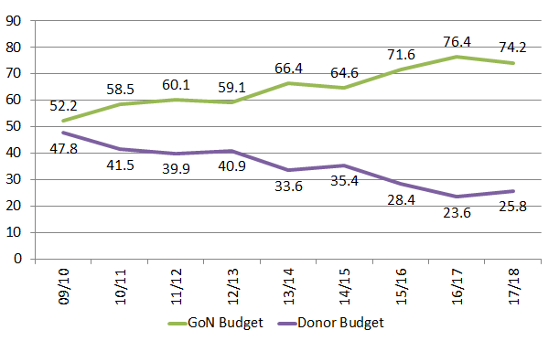

This funding landscape is now in a period of transition, with external resources on a rapid downward trend. The new GFATM funding allocation for malaria will mean a 59% reduction in support in real terms[23] (Figure 4.1.b).

**Figure 4.1.b. Current and projected GFATM support for malaria in Nepal**

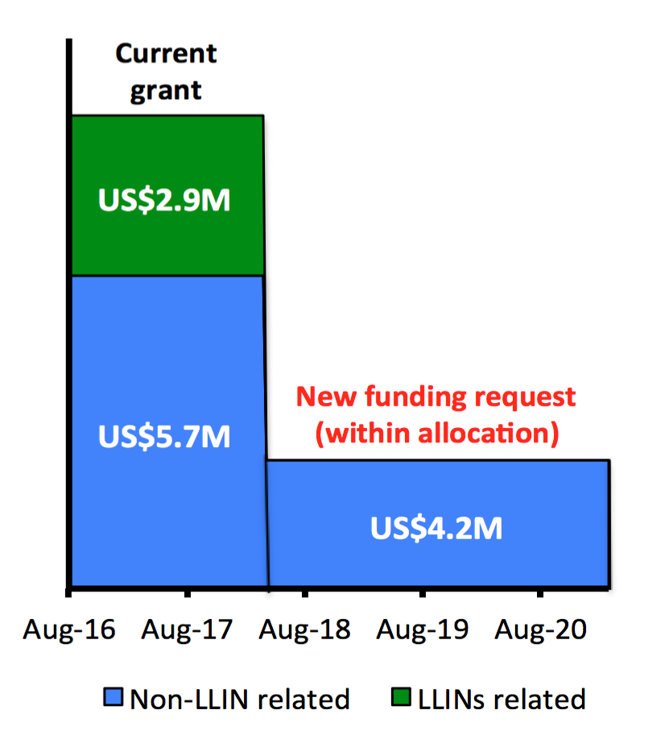

The government has taken important steps towards securing the sustainability of the response by stepping up its contribution. In 2018/19, for the first time, the government committed significant resources for the procurement of LLINs and is increasingly taking over support for commodities and services that have hitherto been supported by the Global Fund.

Ministry of Health in particular has implemented a budget and expenditure tracking system called Transaction Accounting and Budget Control System (TABUCS) which requires all thespending unitsall over the country within Ministry of Health to upload their expenditure reports in every trimester. This allows expenditure tracking more efficiently and timely.

|  |
| --- |
| **4.2 Sustainability** |
| Describe below how the government will increasingly take up health program costs, and actions to improve sustainability of Global Fund financed programs. Specifically,   1. Explain the costs, availability of funds and the funding gap for major program areas. Specify in particular how the government will increasingly take up key costs of national disease plans and/or support health systems; including scaling up investments in programs for key and vulnerable population, removal of human rights and gender-related barriers and enabling environment interventions.   Deepak   1. Describe actions to improve sustainability of Global Fund financed programs. Specifically, highlight key sustainability challenges of the program(s) covered by the funding request, and any current and/or planned actions to address them.   Sean  **(maximum 1 page)** |

a). The projected overall cost of the NMSP during 2018 to 2021 is USD$24.91M. However, the projected costs of the NMSP during the grant period (16th March 2018- 15th March 2021) is US$15.49M. Of this amount,US$13.04M (84%) will be covered by a combination of non-GFATM sources (US$8.83M - 57%) and the ‘within allocation’ request (US$4.21M - 27%). The remaining US$2.43M (16%) has been included in the PAAR. The size of the funding gap varies considerably from one module to another (Table 4.2). For case management (US$ 5.31M) the gap is 28%, but this would be much lower if government support for infrastructure and salaries for service providers were factored in. For vector control (US$6.01M) the gap is 2% - a reflection of the fact that from now on GoN will cover the cost of procuring LLINs and insecticide. For health information systems and M&E (US$1.09M) there is a 37% gap associated with lower priority activities such as countrywide migrant mapping (which it is hoped BMGF will continue to support) and surveys that would be good to conduct but are not essential. For programme management (US$3.09M) the gap is 14%, which includes some TA, which is considered an absolute priority (it is hoped that WHO will find funds for this), and some high priority training and capacity development.

**Table 4.2. Costs, availability of funds and the funding gaps for major program areas.**

|  |  |  |  |  |  |
| --- | --- | --- | --- | --- | --- |
|  | **NMSP Total for Grant Period(2018-2021)** | **Funded** | | **Unfunded** | ***% gap*** |
| GoN[1] and EDPs | GF Within Allocation | GF Above Allocation |  |
| **Case management** | 5,309,703 | 2,630,526 | 1,205,113 | 1,474,064 | 28% |
| **Vector control** | 6,005,582 | 5,542,058 | 340,518 | 123,006 | 2% |
| **HIS and M&E** | 1,086,891 | 436,004 | 248,750 | 402,137 | 37% |
| **Program management** | 3,087,495 | 238,903 | 2,414,166 | 434,426 | 14% |
| **Totals** | 15, 489,671 | 8,847,491 | 4,208,547 | 2,433,633 | 16% |

Planned GoN financial support for the NMSP will fluctuate over the coming years according to programmatic requirements (figure 4.2). Overall GoN financial support is expected to more than double during 2018-20 relative to the previous 3-year period (up from US$4,314,049 to US$8,847,491). The substantial increase in 2018 is associated with the procurement of LLINs.

**Figure 4.2. GoN resources for the NMSP (previous, current and anticipated).**

b). The Programme is also working hard to maximise the cost-effectiveness of all of its activities in an effort to improve sustainability. For example, the current ‘Addendum’ and ‘Operational Framework’ has moved away from the previous LLIN strategy of blanket coverage based on a three yearly VDC level stratification. Current targeting of mass LLIN distribution is based on an annual ward-level stratification of indigenous cases. A multi-pronged strategy for continuous distribution will ensure high coverage for other risk groups.

Although resurgent malaria has occurred in a majority of countries that tried but failed to eliminate malaria, a recent review of resurgence in countries that successfully eliminated, found only four such failures out of 50 successful programmes[24]. Data documenting malaria importation and onwards transmission in these countries suggested that malaria transmission potential had declined by more than 98% since before elimination. This suggests that elimination is a surprisingly stable state in many settings. If this is indeed the case, then it will be possible to cut significantly the projected costs of maintaining elimination, making elimination substantially more attractive for countries acting alone, and making spatially progressive elimination a sensible strategy for a malaria eradication endgame.

The achievement of the NMEPs elimination goal will contribute towards the achievement of Regional elimination goals and ultimately towards global eradication, which will provide the ultimate in sustainability.

|  |
| --- |
| **SECTION 5: PRIORITIZED ABOVE ALLOCATION REQUEST / UPDATE** |

|  |
| --- |
| **Prioritized Above Allocation Request** |
| Provide in the table below a prioritized above allocation request which, if deemed technically sound and strategically focused by the TRP, could be funded using savings or efficiencies identified during grant-making, or put on the Register of Unfunded Quality Demand to be financed should additional resources become availablefrom the Global Fund or other actors (e.g. private donors and approved public mechanisms such as UNITAID and Debt2Health). This above allocation request should include clear rationale and should be aligned with the programming of the allocation for maximum impact. The request should reflect the order in which interventions will be funded if additional resources become available. In line with the Global Fund’s Strategy to maximize impact and end the epidemics, the prioritized above allocation request should be ambitious (for example, representing at least 30-50 percent of the allocation amount). |

|  |  |  |  |
| --- | --- | --- | --- |
| **Malaria** | | | |
| **Module** | **Interventions** | **Amount requested** | **Brief Rationale, including expected outcomes and impact**  (how the request builds on the allocation) |
| Case management | PS case management (other)  IEC/BCC  Policy, planning, coordination and management | US$557,208  US$20,259  US$60,000 | **Absolute**: HR cost at SR for engaging the private sector provider; Orientation cost for SR for engaging the private sector provider; Field visit for engaging the private sector provider; and, Operational costs for the SR.  **Absolute**: Assessment of BCC methodology and approaches to guide policy revision in light of requirements for elimination.  **Absolute**: Additional Technical assistance as required; |
| Case management | Facility-based treatment  Ensuring drug quality  IEC/BCC | US$32,286  US$6,431  US$20,138 | **High**: Kits for community-based healthcare providers to improve the quality of service provision.  **High**: Procure Minilab® test kits and supplies to allow routine point of sale testing of antimalarials by DDA (targeting PS).  **High**: TA for development of IEC documents for elimination; Production and dissemination of IEC materials; |
| Vector control | Entomological monitoring | US$44,472 | **High:** On-going longitudinal surveys of vector distribution, abundance and bionomics in Y2&3. |
| Health information systems and M&E | Routine reporting  Surveys | US$11,638  US$33,428 | **High:** Training on database management and data analysis at Central and peripheral levels to strengthen technical capacity in support of elimination.  **High**: External program evaluation to review progress and inform programme direction (Y3). |
| Program management | Policy, planning, coordination and management | US$307,229 | **High:** International training on program reorientation towards malaria elimination; Capacity strengthening for malaria elimination by SMRU/WHO (this will upgrade the ToT and trickle down approach supported under the ‘within allocation’ amount, which was chosen for its economy); Supply motorcycles, office furniture and equipment, computers band photocopier/printers; and, External program evaluation. |
| Health information systems and M&E | Surveys | US$73,533 | **Medium:** Migrant mapping (in partnership with TU & UCSF);Facility- and community-based surveys (including LLIN utilisation) in different risk populations to inform programme direction. |
| Case management | PS case management (other)  Ensuring drug quality  Facility-based treatment | US$35,162  US$11,742  US$34,440 | **Medium**: Training of other private sector service providers (pharmacies, private companies and selected drug vendors) on National Treatment Protocol.  **Medium**: Support facility visits by enforcement teams in cases where inappropriate drugs are identified.  **Medium**: Procure and supply 15 new replacement microscopes (Y2); Refurbish Surkhet microscopy laboratory (Y2). |
| Vector control | Entomological monitoring  Other vector control measures | US$61,050  US$1,373 | **Medium:** Provide training on basic malaria entomology for support workers to maximize capacity of entomological teams to support elimination.  **Medium:**Larval source management where vector breeding sites are ‘few, fixed and findable’ in order to maximize cost effectiveness and sustainability of operations. |
| Program management | Supporting procurement and supply management  Policy, planning, coordination and management | US$54,640  US$300,839  US$10,512 | **Medium:** Support QA/QC of Health Product/Pharmaceuticals (as per GFATM rules); Provide LMIS training workshops for RHDs, DHOs, DPHO, storekeepers, accountants and other officers for GFATM activities to strengthen capacity in-line with the additional workload associated with elimination.  **Medium:** Orientation meetings/trainings for community involvement in malaria elimination (massive scale-up of approach supported under the ‘within allocation’ amount).  **Medium**: Prepare annual HR development plan. |
| Case management | IEC/BCC | US$351,696 | **Medium:** Support broadcasting of IEC messages over radio/FM.Hold regular orientation meetings to maximize community involvement in malaria elimination. |
| Health information systems and M&E | Routine reporting | US$283,538 | **Medium:** Procurement of mobile phones/tablets for electronic based malaria reporting.Mapping of all villages in endemic areas based on GIS.Training workshops to strengthen PSM, M&E, finance and programme management. |
| Vector control | Entomological monitoring | US$16,110 | **Low:**Monitoring the durability and efficacy of LLINs to inform future procurement. |
| Program management | Policy, planning, coordination and management | US$2,044 | **Low**: Provide training on leadership and management at Central, Regional and District levels |
| Case management | IEC/BCC | Low US$103,863 | **Low:** Commemoration of World Malaria Day at Central and Districts levels Level to raise awareness and secure funding. |
| **TOTAL AMOUNT** | | US$2,433,633 |

**Mandatory attachments:**

CCM eligibility, compliance and sign-off.

Performance Framework.

Programmatic gap tables.

Funding Landscape.

1. Robust data are not available at present, but experts believe that approximately 50% of malaria cases are managed in the PS.
2. Any case in which symptoms appeared within 1 month of return from an endemic country outside Nepal is considered to be imported.
3. The Terai – the low-lying foothills and plains that run the length of Nepal’s southern border with India.
4. See description of the 2006 outbreak in Banke in the Operational framework (Annex 4, p11).
5. 96% of imported cases in 2016 were amongst adults and 90% of these were amongst men.
6. http://www.unhcr.org/afr/news/latest/2015/11/564dded46/resettlement-bhutanese-refugees-surpasses-100000-mark.html
7. Community consultation meeting reports are annexed in the ‘Community consultation’ folder (annex 13).
8. The PR was changed at the request of GFATM to address management related issues.
9. Performance has risen from C2 before SCI assumed the role of PR to A1 (Nov 2016-Mar 2017).
10. e.g. 4 disease control section chiefs in 2.5 years.
11. By October 2017 the Logistics Management Division (LMD) (with WHO) will review and revise existing guidelines on medical waste disposal. A committee will then be formed (November 2017) to oversee mitigating actions. LMD will coordinate with the Auditor-General’s Office to write-off unusable commodities. Where possible commodities that have been written-off will be auctioned. Expired medicines will be disposed of following “WHO safe disposal practices for expired medicines”. LMD will work with funding partners to arrange for suppliers to return expired insecticides/LLINs to their manufacturers for revalidation or proper disposal.
12. Sub-activities were identified as ‘Absolute’ priority (life-saving or critical to the elimination effort), ‘High’ priority (important for basic program functioning), ‘Medium’ priority (required for program to be fully functional) and ‘Low’ priority (activities that would be useful but not essential for the full functioning of the programme) based on an analysis of a combination of various factors including ‘expected impact’, ‘cost’ and ‘malaria risk’. The criteria used to identify each priority level were qualitative, rather than quantitative. The exercise was carried out by a panel of experts as part of the development process for the NMSP’s ‘Operational framework’. The prioritization was then fine-tuned in consultation with stakeholders, taking into consideration GoN support and the GFATM funding envelope. The results are presented in column ‘E’ in worksheet ‘Budget & Workplan’ in the detailed NMSP budget workbook (‘Annex 11. Budget for proposalGF- 21Aug 2017.xlsx’).
13. Reorientation to health post level will be completed in 27 endemic Districts under the existing grant.
14. Materials are likely to include inter-personal communication (IPC) aids, audio and video sketches and presentations, billboards, posters, brochures, articles, pamphlets, modules for the school curriculum, and free automated SMS messages for migrants returning home from abroad.
15. Key messages are likely to cover: Care and use of LLINs and washing practices; The importance of immediate use of LLIN; The importance of sleeping under an LLIN; The dangers of fake, sub-standard and inappropriate antimalarials; The importance of seeking treatment early from qualified healthcare providers; and, The importance to the community of all cases receiving immediate treatment in an elimination setting.
16. All LLINs will be given to recipients, never loaned.
17. LLINs are considered to be viable for 3 years post distribution.
18. In order to maximize cost effectiveness and sustainability, as of 2017, mass distribution only targets Wards with indigenous cases.
19. Insecticide choice will take into account safety, residual efficacy, cost effectiveness, availability, existing susceptibility of vectors, and likely effect on susceptibility of vectors.
20. e.g. in outbreak areas where IR may be responsible for the outbreak and in areas at high risk of IR, such as areas with high agricultural pyrethroid use.
21. Refer to the [Global Fund 2017 Eligibility List](http://www.theglobalfund.org/en/fundingmodel/process/eligibility/)for income level. LMI and UMI countries have specific requirements in terms of the focus of applications as set forth in the Global Fund [Sustainability, Transition and Co-Financing Policy](http://www.theglobalfund.org/en/fundingmodel/process/cofinancing/).
22. VBDRTC is based in Hetauda, 4 hours drive south of Kathmandu.
23. Excluding funds for LLINs, which will not be required from GFATM any longer.
24. Smith, D.L. *et al*., (2013) A sticky situation: the unexpected stability of malaria elimination. *Philosophical transactions of the Royal Society of London. Series B, Biological sciences*, 368, (1623), 20120145.