Provincial Consultation Meeting – CSO Constituency
Event Report
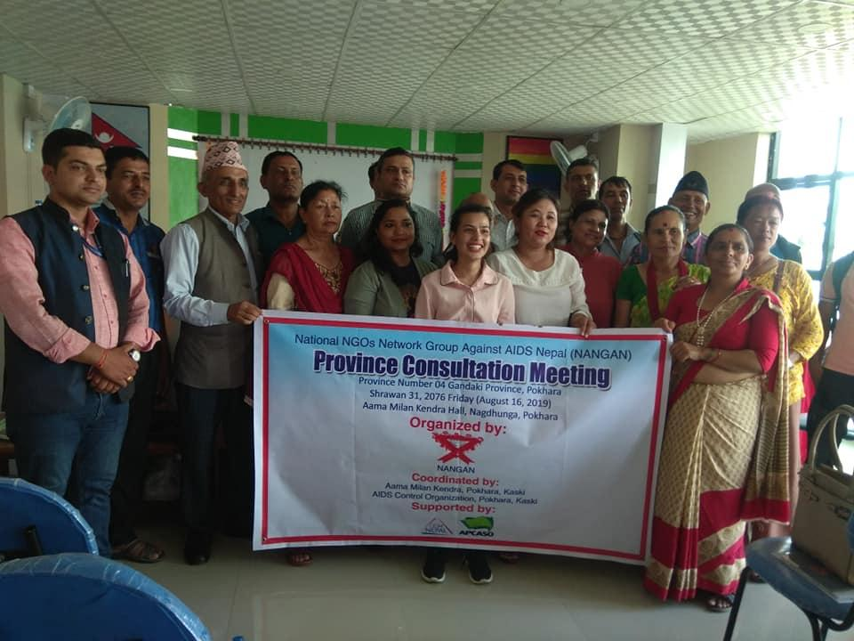
Date: August 16, 2019 Venue: Aama Milan Kendra, Pokhara Kaski

Submitted To
APCASO, Thailand and CCM Nepal
Submitted By:
National NGOs Network Group Against AIDS Nepal (NANGAN)
Bijulibazar, Kathmandu, Nepal
Email: nangan.network@gmail.com
Web site: www.nangan.org.np
Introduction
National NGOs Network Against AIDS Nepal (NANGAN) is the umbrella organization of the NGOs working in the HIV sector. It has 120 member organizations all over the country working for the PLHAs, Key affected populations and general public. NANAGN represents the CSO Constituency in CCM from HIV sector consisting of 2 main and 2 alternative members. As per the CCM Nepal letter, NANGAN has decided to organize the consultation Meeting (two episode) for the effective constituency involvement and their strengthening and empowerment. For this, NANGAN in consultation with CSOs Constituency CCM members has planned to conduct the second events Province consultation meeting with its network members and Civil Society representatives held in Gandaki Province Pokhara in 16th August 2019 and this report highlights on the same.
Preparatory Meeting with CCM Members and NANGAN Executive Committee
NANGAN held a preparatory meeting with the CCM Members on 12 August 2019 at its secretariat office Bijulibazar. Discussing on this subject, the meeting decided to arrange the Province consultation meeting in August 16 and planned the agendas and participants accordingly.
Meeting Objectives
The main objectives of these consultations were to bring the Province voices from the constituency through networks and share it to the CCM forum via CCM members.
The specific objectives are:
- To examine the current situation of HIV&AIDS and discuss about the roles of CCM Nepal and CSOs.
- To collect the province level issues from the consultation meeting participants and build common consensus among the others.
- To document the consultations findings and compile/submit the report accordingly.
Participants
34 participants took part in this meeting including NANGAN members, Networks/Civil Society Organizations, Representatives working in HIV, TB and Malaria and the other relevant stakeholders.
Facilitators
The key facilitators were Ms. Indira Rana Magar, Mr. Dhirendra Lamsal CCM Members Ms. Anju K.C. Alternate CCM. Member and Mr. Dal Bahadur G.C., President, NANGAN.
Venue
The meeting was held at Aama Milan Kendra Meeting Hall, Pokhara, Kaski
Date and time
16 August 2019, from 11.00 Am to 3 Pm
Consultation Meeting Agendas
- Welcome and Objective highlight
- NANGAN and its contribution in national response
- HIV&AIDS Update
- Orientation about the CCM and its ROB
- Discussion and interaction on the Province issues
- Way forward
Proceeding of the Province Consultation Meeting
Welcome and objective Sharing
Ms. Anju K.C. Alt. CCM Member and MC of the day announce to start the session. At the beginning, Mr Dhirendra Lamsal, CCM Member welcome to the participants. He also shared the meeting objectives as mentioned above.
Presentation by NANGAN
NANGAN President Mr. Dal Bahadur G.C. presented firstly about NANGAN as well as the Global and National scenario of HIV&AIDS.
He firstly explained about the NANGAN VMGOs and its contribution in the national policy and the national response. He later presented the Global data of HIV 2018 and Nepal Estimates of HIV infections – 2018, then after he further explained the data of people living with HIV&AIDS in 2018. Lastly, he explained about the Estimates of Key Populations. These presentations were based on the facts sheet published by the National Center for AIDS and STD Control (NCASC)
NANGAN's Vision
Society without AIDS
NANGAN's Mission
- To mitigate the transmission of HIV and ensure the dignified life for PLHAs by means of contributing to the effective implementation of the national HIV and AIDS strategy through advocacy and capacity building of the member organizations.
NANGAN's Goal
- Contribute effectively to the reduction of current HIV& AIDS prevalence rate in line with a new vision of ending the AIDS epidemic by 2030 and goals to achieve optimized Identify, Reach, Recommend, Test, Treat and Retain (IRRTTR) for 90-90-90 and combination prevention by 2020.
NANGAN’s Objective
The objectives of NANGAN are to:
- Identify gaps and advocate for an effective policy at national/local level in order to ensure the rights of the PLWHA, Risk population including Migrants cross broader issues, SRHR and other vulnerable groups and support for implementing the program for addressing their issues effectively
- Promote social protection and service integration in SRH, TB and Malaria sector and linked with livelihood and capacitate its member organizations through training and establishing effective network in all 7 provinces and support for regularize effective monitoring systems in 77 districts.
- Establish a knowledge resources facility in the HIV/AIDS sector in smoothing and strengthening network, update profile and best practices information sharing and capacity building among member organizations and other stakeholders
- Coordinate, collaborate and cooperate with GO/I/NGOs, civil society and private sectors working for HIV/AIDS, TB and Malaria preventing, control care and support by mainstreaming the development sector in HIV for its sustainable solution
Recent works of NANGAN
- Finalize NANGAN Strategy Plan for BS 2076 -2080
- Representing CCM from CSO Constituency
- Dissemination of the CCM Meeting 103rd Minute
- Supported for electing the CCM members from CSO Constituency
- Issue based interactions and lobbying in Migrant Labor Health issues
- Collecting issues from the provinces for advocacy and lobby to the effective response
- Developed concept notes on Cross boarder migrants and multi sectoral response in HIV&AIDS
- Supported nutritional foods and endowment fund for CABA
- Organized free Eye health camp at Kritipur
- Participating in various meeting and workshop for provide inputs or better Plan and policies
NANGAN Possible Actions
- Internetwork coordination Meeting for discussing the national gaps and its response
- Sensitization and Capacity building of the members and NGOs in context to country response and reaching to the unreached
- Orientation and Capacity building to the local bodies and stakeholders
- Psycho-socio Counseling training to the KAPs
- Collect gapping/lacking Information and share to the members and stakeholders from central to grass-root and vice-versa
- Sensitize, Advocacy and lobbying to the local bodies, provinces and federal level in HIV issues
- Assessments of Clients Satisfactions on services and collection and publications of the best practices
World AIDS Epidemic 2018 (UNAIDS)
In 2018, an estimated:
- 37.9 million [32.7 million–44.0 million] people globally were living with HIV
- 23.3 million [20.5 million–24.3 million] people were accessing antiretroviral therapy
- 1.7 million [1.4 million–2.3 million] people became newly infected with HIV
- 770 000 [570 000–1.1 million] people died from AIDS-related illnesses
Nepal Estimates of HIV Infections-2018
;+qmldtx?sf] jlu{s/0f | ;+Vof
hDdf ;+qmldt ;+Vof | @(*&*
PrcfO{eL ;+qmd0f b/ -!%—$(_ | )=!$
PrcfO{eL ;+qmldt k'?if | !&^(@ -%( k|ltzt_
PrcfO{eL ;+qmldt dlxnf | !@!*^ -$! k|ltzt_
PrcfO{eL ;+qmldt jfnjflnsf -hDdf ;+qmldt ;+Vofdf_ | !#)# -$=# k|ltzt_
Gfof PrcfO{eL ;+qmldtx? | *&#
(Elevating Vertical Transmission) jf cfjZos cfdfx? | @!*
P8\; ;DalGwt d[To' | (!^
->f]tM /fli6«o P8\; tyf of}g /f]u lgoGq0f s]Gb _

Estimation of Key Populations 2016
Key Populations sf]] jlu{s/0f | ;+Vof
;'O{ 4f/f nfu' kbfy{ lng] (People who inject drugs) | #)*^*
k'?if ;dln+UfL (Men who have sex with Men) | ^)###
of}gsdL{ dlxnf (Female Sex Worker) | $()!#
k'?if of}gsdL{ (Male Sex Worker) | !*@*&
Tf]>f] ln+uL (Transgender People) | @!$^)
->f]tM /fli6«o P8\; tyf of}g /f]u lgoGq0f s]Gb _
Estimated Key Population affected by HIV- 2018
hg;+Vof ;d'x | k|ltzt
;'O{ 4f/f nfu' kbfy{ lng] k'?if (Male people who inject drugs) | #
k'?if ;dln+UfL (Men who have sex with Men) | (
of}gsdL{ dlxnf (Female Sex Worker) | @
k'?if of}gsdL{ (Male Sex Worker) | @
Uf|fxsx? (Clients) | (
sd hf]lvd o'Qm k'?ifx? cfk|jf;L sfdbf/x? ;d]t (Low risk males including migrants) | #^
sd hf]vLdo'Qm dlxnfx? (Low risk Females) | #(
->f]tM /fli6«o P8\; tyf of}g /f]u lgoGq0f s]Gb _
About CCM and its update
Ms. Indira Rana, CCM Member presented about the CCM Nepal history, Mandate of the CCM Nepal and the composition of CCM members.
Country Coordination Mechanism
The CCMN is a multi-sectoral national platform to coordinate and facilitate Global Fund activities to fight against AIDS, TB and malaria in Nepal.
- The mandate of the CCMN is to mobilize a national multi-sectoral response to develop and submit funding application to the Global Fund to scale up the fight against AIDS, TB and malaria, and to oversee and support the implementation of activities. Besides, CCM is also mandated to select PR/PRs as well as approve any changes and amendments in programme and budget proposed by PR
- The aim of the CCMN is to enhance performance of the Global Fund activities in Nepal in partnership with stakeholder constituencies, to promote efficient program implementation, to avoid duplication by harmonizing Global Fund activities with other programs throughout Nepal.
Background
- Country Coordinating Mechanism (CCM) Nepal, established in 2003 to access and oversee global fund financing that supports and compliments national strategies on three diseases.
- Principal Recipient, since then UNDP, FPAN, PSI, Ministry of Health and Save the Children is the designated/ chosen by the CCM to receive funding from the Global Fund, implement programs, and distribute funds to sub-recipients.
- CCM Secretariat, responsible for day-to-day operations, coordinating meetings and assist the CCM in overseeing grant implementation and hosted by then Ministry of Health Nepal
Current Situation
- Principal Recipient, Save the Children is managing overall global fund grants as PR in close collaboration with Ministry of Health, Civil Societies and External Development Partners.
- CCM Secretariat, is hosted by Ministry of Health but it functions independently to run day-to-day operations, coordinating meetings and assist the CCM in overseeing grant implementation.
CCM Member Composition today – 17 members
Constituency | Total Member | Sub-Constituency
Government | 5 | 2: Ministry of Health  3: Ministry of Finance, Ministry of Women  Children and Social Welfare, Ministry of Federal  Affairs and Local Development
NGO/CSO | 2 | 2: NGO and CBOs
People living with or affected by the diseases | 3 | 1: People living with HIV and representing people living with HIV  1: People affected by TB and representing the people affected by TB;  1: People affected by Malaria, or the expert representing non-government organization or institution working in the area of Malaria
Key affected populations | 3 | 1: People who inject drug (PWID  1: Men who have sex with men and transgender people  1: Female Sex workers  1: Migrants  1: In close setting (prison)
Academic/ Research institution | 1 | 1: Academia/ Public sector autonomous health research institution
Private Sector | 1 | 1: Representative of private for-profit organization
Multilateral and Bilateral | 2 | 1: Representatives of Multilateral agencies  1: Representatives of Bilateral agencies

Executive Committee
The CCMN shall establish an Executive Committee comprising of five (5) members, namely: The Chair, the Vice-Chair, the Chair of the Oversight Committee, and two CCMN members from EDP (1 from bilateral and 1 from multilateral) with no COI). CCMN must ensure the representation of the non-government sector in Executive Committee either as the CCMN Chair or Vice chair or the Oversight Committee Chair.
The CCMN Secretariat will be the Secretariat to the Executive Committee.
Oversight Committee
To ensure the most effective possible oversight of programs in Nepal financed by the Global Fund, and related processes, the CCMN shall establish an Oversight Committee.
- The Oversight Committee membership shall consist of a Chair, a Vice-Chair, and minimum six to maximum 11 Ordinary Members:
  - Specific disease experts (HIV, TB and Malaria)
  - Program management
  - Financial management;
  - Procurement and Supply Chain management; and
  - Representatives from PLWD, KP and NGO constituencies.
- CCMN membership is not a prerequisite for appointment to the Oversight Committee, except for the position of Chair and Vice Chair.
- Persons who are employed by a Principal Recipient (PR), a Sub-Recipient (SR), a Sub-Sub-Recipient (SSR), or who otherwise have a conflict of interest within the terms of the CCMN Conflict of Interest Policy are ineligible for membership of the Oversight Committee.
CCMN Secretariat
- The CCMN shall establish a Secretariat headed by a Coordinator. The Office of the CCMN Secretariat shall be situated in Katmandu, Nepal.
- The Coordinator and the CCMN Secretariat shall execute the day-to-day functions as delegated by the Executive Committee. The Coordinator and the CCMN Secretariat supports the decision-making and other functions of the CCMN Executive Committee.
- The Coordinator of the CCMN Secretariat attends meetings of the CCMN and is not a voting member.

Responsibilities of CCMN Members
CCMN members have the following responsibilities:
- All CCMN members are expected to attend CCMN meetings and contribute actively in accordance with their roles as CCMN members, and in line with their resources and areas of expertise.
- To adhere to the provisions of this Rule of Business and any policies adopted by the CCMN;
- To adhere to guidelines of the Global Fund issued from time to time in respect of Country Coordinating Mechanisms and their members;
- To attend and participate in CCMN meetings in a timely and responsible manner;
- To ensure the participation of the alternate members in CCMN meeting/s, if he or she is unable to attend.
- To share relevant experiences and information at CCMN meetings;
- To support and adhere to decisions made by the CCMN;
- To regularly report on CCMN proceedings to organizations and individuals from the constituency represented by the member; and provide annual calendar of their constituency consultation to the CCMN Secretariat;
- To abide by the CCMN Conflict of Interest Policy;
- To participate in reviewing performance of grants, such as through grant scorecards, Global Fund Review Team, site visits, or summary results.
CCM: Experience and Challenges
- Managing Conflicts of interest and uniform understanding
- Poor representation of sectors (members believe they represent only their organization; motivation is to ensure my organization gets GF funds)
- Confusion between the CCM and other national bodies
- Poor or non-existent oversight, little support of PRs to resolve cross-cutting problems & bottlenecks
- Limited and dependent with Global Fund Grants
- Limited knowledge among CCM Members on CCM function and their role
CSOs engaging HIV Engagement Plan
One of the activities out of several activities done to make CCM eligible CCM is the development of Community Engagement Plan. CCM member also developed this plan in close coordination with all the members so that there is no duplication, with the technical support from APCASO and the major activities planned are as below:
- Monthly Coordination Meeting
- Information Sharing and Coordination Meetings with Network Ex Com Members
- Re-documentation of active CS members from all the Province, province wise and development of email network
- Communications with CCM Secretariat
- Attending CCMN- Meetings and communicating on behalf of CS members
- Provide input to NCASC and other development partners as a CCMN member/engage CS-network members
Gapping/lacking in HIV Response
Ms. Anju K.C., NANGAN Vice-president and CCM Alternate member briefly shared about the issues from the provinces 1, 3 and 7. Then after the participants were requested to share their province issues.
Discussion on the issues of Gandaki Province number 04
Ms. Anju K.C. requested participants to present and discuss about the issues of Gandaki provinces: The participants pointed out the following issues:

Manoj Gurung, Kaski
- Its low epidemic Province but concentration is in Kaski
- Kaski districts cases are 815 and here is no any program fro labor migrants
- Installed Viral load machine, but it is not working
- There is many lacking in social part and Stigma and Discrimination
- There is minimal work in nutrition
- There is still need of networking and initiation for the local resource mobilization
- CSO can play supportive role to PLHIV and risk population by listening and raising their issues
Pankaj Ghimire-Naulo Ghumti Nepal
- Time taking 2 to 3 days for the testing – difficulty for facilitation
- The Virol load report is not yet received from NPHL since February – medicine is continued by self-decision
- It is difficult to go in ART, for those who cannot afford at least Rs 2000 to 2500
Shriram Kandel, Tanahun Support Group
Program started at Tanahun since 2061 Tanahun Support Group is working since 2063
- Tanahun districts cases are 317 among them 26 are children
- Since <18 years CABA are getting Rs 1000/monthly but It is being very difficult for the 18+ years
- The viral load report is not yet received send on April 22
- There should also pay to the CD4 test
- There should be the provision of providing 3 months ART at a time
- CLT program is being success to identify new cases (2 reactive among 27 test)
Arjun Bahadur Gharti, CSG, Parbat
Problem for 18+ years CLHIV to work in the country and outside
What kind of support can provide by the government for the 18+ CLHIVs?
Chaumaya Gurung, Shyangja Support Group, Syangja
CD4 Service is avaiv at District Hospital but virol load service is from Gandaki Hospital
Blood is dropped for the testing, but the message comes in delay about the blood damaged
Susmita Puri, AHF Kaski
CD4 machine is not functional time to time and the resents is not coming in time
Nutrition also not coming in time
Nanibabu Dhakal, DHO Kaski
- Budget is lower and difficult to coordinate with the stakeholders eg no budget in WAD Celebration
- HIV/TB infection is also seen
- Disturb of Viral Load machine time to time, private sector also providing VL services
- Hospital machines are dis-functional due to the outside clinic
- High S&D in HIV (eg. Child were restricted from Lekhnath School)
- No continue of Needle Syringe exchange program
- Low understanding of HIV issue at local level
Ganesh Gautam, Kaski Jail
- 105 viral infected people are living in Kaski Jail
- 12 lakhs budgets in Health budget, social security budget also used in health program
- Refer to Ktm for the serious patients

Speeches
Saroj Baral. NGO Federation, Kaski
- 143 NGOs affiliated in NGO Federation, Kaski
- Treatment, refer and advocacy are the main component
- More Awareness program is needed for identifying the Hiding cases
Nawaraj Paudel, Urban Health Promotion Center
- 10 staff are available and provided 10 types of services including Prevention, OPD test, search and destroy, ANC and Maternity care
- No PMTCT Kit available
- Mass Awareness is needed for prevention and reducing transmission
- Effective coordination is the essential part for program effectiveness
Ganesh Gautam, Kaski Jail
- Lack of Space and budget
- Can go in a coordinated way
Indira Paudel, AMK, Kaski
- AMK has great contribution in Reproductive Health
- Positive group are doing more but there is lack of coordination
- HIV is the common issue, hence all stakeholders should move together
- We should start from own place for prevention
- Peoples representatives should be more responsible rather than project based
- Social Welfare Ministry and District Coordination Committees participation is important
Indira Rana, CCM Member
- Self-motivation and regulation are important
- We can do ourselves, but we can also seek the private donor
- We should identify the Sustainable solution
Vote of thanks and closing
Mr. Dal Bahadur G.C. NANGAN President remind the Consultation meeting achievement, which were: update national data and NANGAN efforts, Collection of Province level HIV&AIDS issues, Introducing CCM Nepal and its recent works for constituency engagement and capacity building. NANGAN president thanked to all especially the CCM members, Representatives from AHF Nepal and Representatives from District Health Office, Kaski Jail, Urban Health Promotion Center for their valuable participation and contribution to bring this event successful. Lastly, vote of thanks was provided to all the participants and Aama Milan Kendra Pokhara for their close coordination and providing the hall.

Annex-1 - Meeting Schedule
Province Level Consultation Meeting- CSO Constituency
MC: Ms. Anju K.C., Vice President NANGAN, Alternative CCM Member
S.N | Activity | Time | Responsible person
1 | Registration and Tea | 11:00 – 11:15 | NANGAN/AMK
2 | Welcome and sharing meeting objectives | 11:15 – 11:20 | Dhirendra Lamsal, CCM Member
3 | Introduction | 11:20 -11:30 | Anju K.C Alternative CCM Member
4 | National HIV update and Introducing NANGAN and its efforts in supporting national policy and programs | 11:30 – 11:40 | Dal G.C., NANGAN President
5 | Introducing CCM and its Rules of Business | 11.40- 12:00 | Indira Rana magar CCM Members and Secretariat
6 | Update of last CCM Meeting and Consultation Meeting at Kathmandu | 12:00 – 12:15 | Anju K.C , CCM Member
7 | Presentation and Discussion on the issues from the provinces and consultation with the participants | 12:15 – 13:00 | Anju K.C. Vice President NANGAN, Alternative CCM Member
8 | Speeches from the Guests and Participants | 13:00 – 13:15 | CCM Nepal, Network Rep, Participants,
9 | Way forward | 13:15 -13:30 | Existing CCM Members
10 | Vote of thanks | 13:30 -13:35 | Dal Bahadur G.C., NANGAN President
 | High Tea | 13:35 onwards

Annex -2 Photography
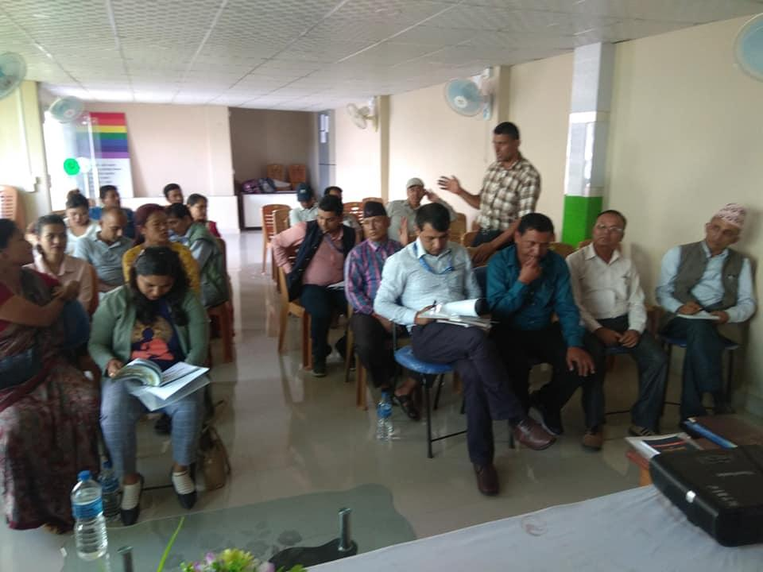
Figure 1 Participants during sessions
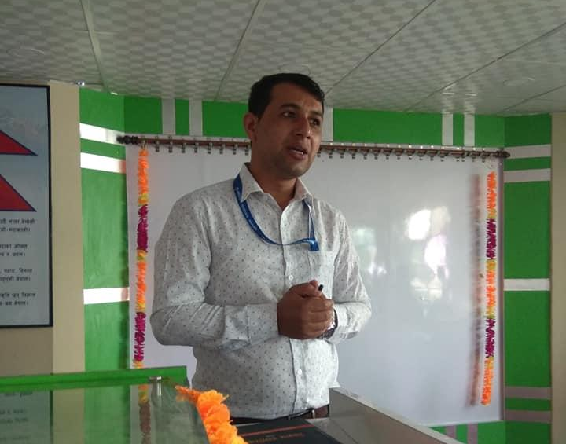

Figure 2 Delivering speech by Mr. Ganesh Gautam, Kaski Jailer

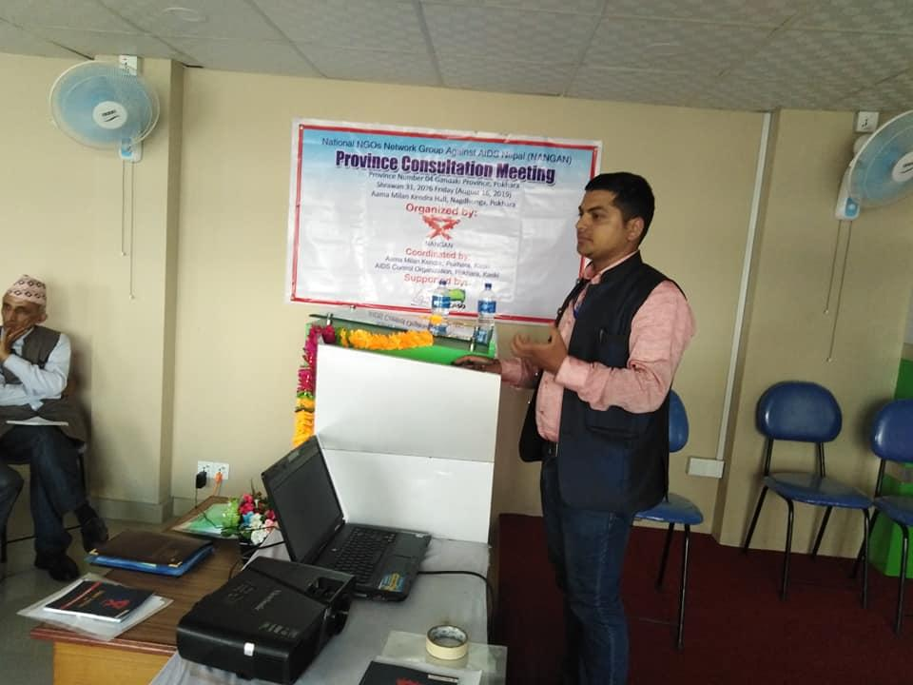
Figure 3 Sharing by Mr. Nawaraj Paudel, Urban Health, Pokhara Metropolitan City Representative

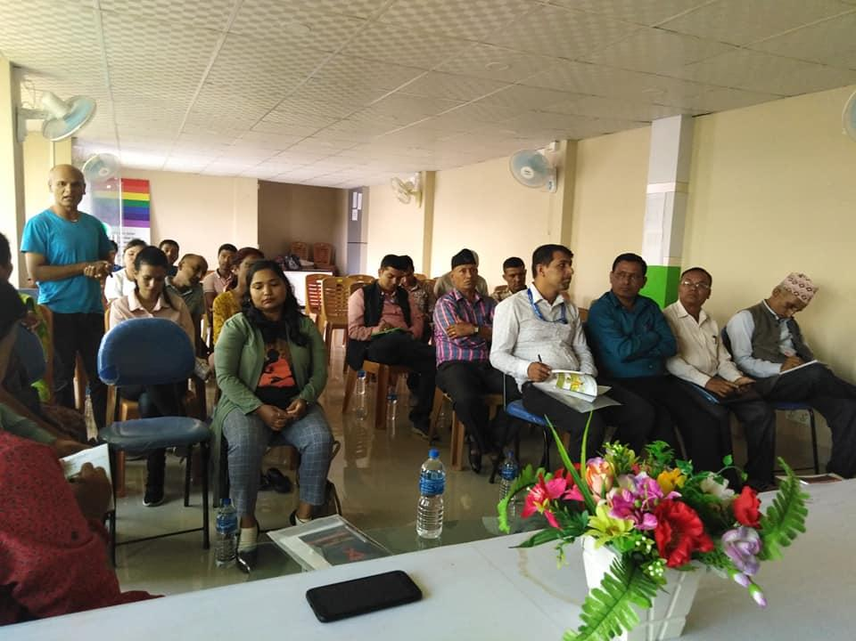
Figure 4 Sharing by Mr. Manoj Gurung Community Support Group Kaski Representative

