**Report on Community Consultation Meeting**

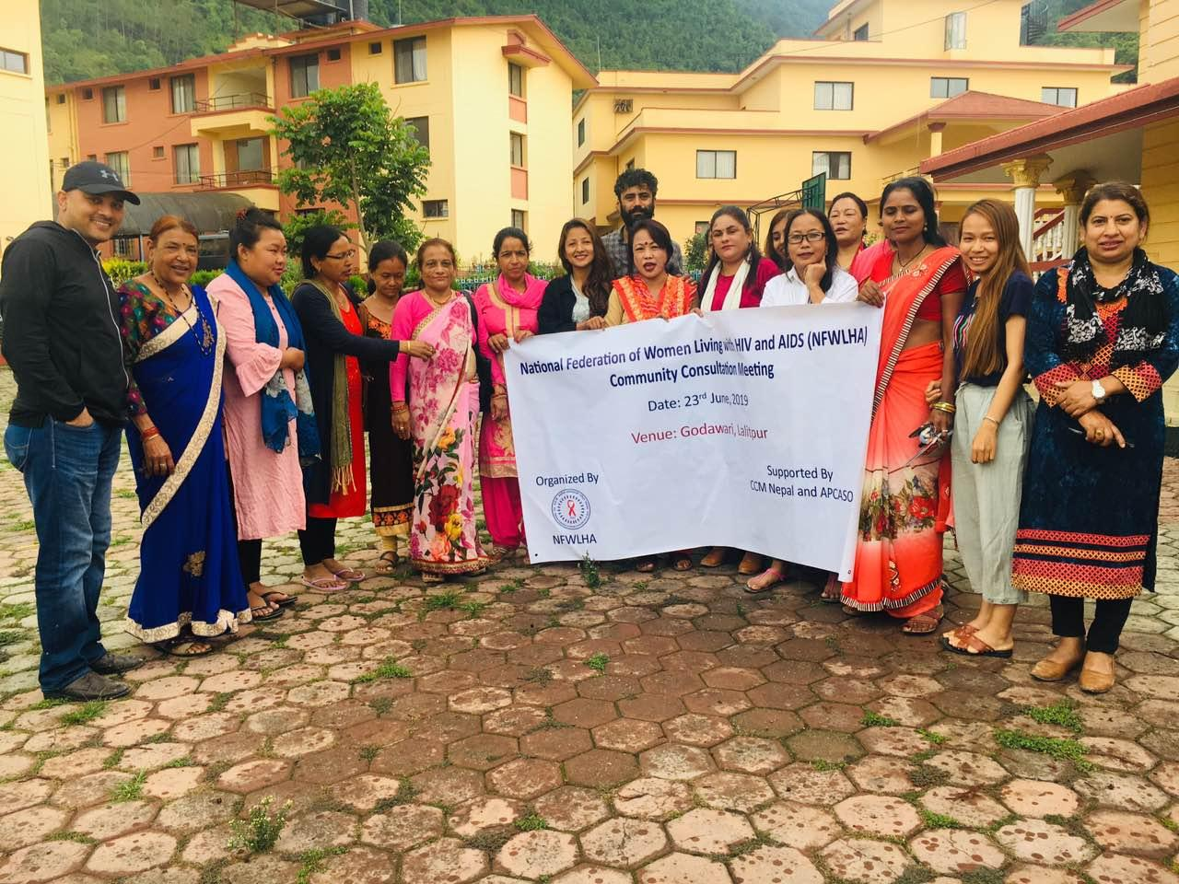

Date: 23rd June, 2019 Venue: Godawari, Lalitipur

**National Federation of Women Living with HIV and AIDS (NFWLHA)**

New Baneshwor, Kathmandu, Nepal

Email: [nfwlha007@gmail.com](mailto:nfwlha007@gmail.com)

Web site: [www.nfwlha.org.np](http://www.nfwlha.org.np)

**Background**

National Federation of Women Living with HIV and AIDS (NFWLHA), formerly known as the Women’s Network against HIV & AIDS (WONAHA), was initially established as a loose network in 2006 and was officially registered in 2007 with a vision to create a just and equitable society for women and children infected and affected with HIV, so that they can live productive, empowered and dignified life, free from stigma and discrimination. Underpinned with guiding principles of gender equity and human rights, evidence-based planning, programming and policy-advocacy, NFWLHA has broadened its strategic intervention areas over the last nine years, focusing mainly on strengthening and capacity development of network, knowledge management for evidence-based policy advocacy and community system strengthening. Currently, there are 35 community-based organizations (CBOs) affiliated to NFWLHA, all led by women living with HIV (WLHIV), spread over 22 districts (out of 75 districts) of Nepal.

Still WLHIV and CABA are facing the various issues and problems. As there is not the appropriate platform to shares the issues of WLHIV and advocate (raise the voice against the issues) which is one of the main obstacles for WLHIV. Therefore, to minimize the stigma and discrimination and empower the WLHIV to advocate for the issues, there should be the collection of the issues. Because until and unless if we didn’t raise the voice and collection of the issues for oneself no one would advocate for us. Therefore, to better understand about the issues of WLHIV, CABA, YPLHIV and to orient them about the Global Fund, CCM and their rights to select member NFWLHA conducted the community consultation meeting at Godawari which was technically and financially supported by CCM Nepal and APCASO.

**Objective:**

* To provide the information regarding the Global Fund, its mechanism and CCM.
* To identify issues and challenges faced by WLHIV, CABA, YPLHIV and way forward.

**Training Team**

One day Consultation Meeting was facilitated by Sara Thapa Magar, President and Ms. Chhetra Kumari Gurung, Program Officer of NFWLHA. As well as Supported by Mr. Achut Sitoula CCM Vice Chair and Mr. Sandesh Neupane CCM Coordinator.

**Methodology:**

* The training was conducted with a participatory approach. Discussion method was also applied.

**Activity Details**

The one-day consultation meeting was commenced with an ice-breaker that required the participants to introduce themselves name, organization and the post. Ms. Sara Thapa Magar, President of NFWLHA shared the objectives of the consultation meeting.

Mr. Achut Sitaula, Vice Chair of CCM Nepal and Mr. Sandesh Neupane, Coordinator of CCM Nepal shared about the Global Fund and CCM Nepal. They shared that Country Coordinating Mechanisms are national committees in each country that submit funding applications to the Global Fund on behalf of the entire country. In CCM there are representatives from government, the private sector, technical partners, civil society and communities living with the diseases.

They also shared that we from PLHIV there are representatives to raise our issues and to ensure budget for the community. Each PLHIV has rights to select the right select the member for the CCM for the community who will raise the issues. They also shared about the roles and responsibilities of CCM Nepal; they also shared about the mechanism of CCM, PR and SR.

After the brief discussion about the CCM and GF Ms. Sara Thapa Magar from NFWLHA divided participants into three groups where each group will discuss about the issues of single women, PLHIV and CABA and the way forward for the solutions.

**Single Women**

|  |  |
| --- | --- |
| **Key Issues** | **Ways Forward** |
| 1. Stigma and discrimination from the family, society. 2. Deprived of the property. 3. Lack of self-empowerment programs. 4. Due to low economic condition difficult to establish their own business inspire of the skills. 5. WLHIV deprived from the women related activities. 6. Lack of empowerment as per the skill of WLHIV. 7. Must take the ART hiding from the peoples. 8. Deprived from the various opportunities as being WLHIV. 9. Difficult to get the rent as being PLHIV. 10. No free treatment facilities for PLHIV for various checkup. 11. No free treatment for the cervical cancer | 1. Stigma and discrimination Reduction Training 2. Income Generation Program 3. Capacity Development Training |

**CABA Children**

|  |  |
| --- | --- |
| **Key Issues** | **Way Forward** |
| 1. Lack of birth Certificate. 2. Not friendly environment for taking ART. 3. Lack of Education Support, Treatment Support. 4. Rs 1000.00 is not enough for the CABA. 5. Future problem (Job, Marriage and career) | 1. Support from government and community. 2. Should link with government, private and college must link. 3. Treatment support should be provided in any related illness. 4. NGO’s and government must look forward to the CABA like providing awareness, training programs. 5. Should have to give more priorities for CABA for job in any field. |

**Young PLHIV**

|  |  |
| --- | --- |
| **Key Issues** | **Way Forward** |
| 1. Have to take the ART in schools and college by hiding from friends. 2. No information about the side effect of ART for the adolescents. 3. Lack of programs and activities for Adolescents. 4. Lack of data of young peoples. | 1. Good counseling and program work plan for young population. 2. Proper Information about the side effect of ART. 3. Care and support for young population those who are not involve in job. 4. Should collect the data for young PLHIV. |

Above are issues of single women CABA, PLHIV and way forward presented by the community members from each group.

Closing remarks by Ms. Mana Sherchan, secretary of NFWLHA thanked all participants for participating in the consultation meeting. Specially grateful towards the CCM Nepal and APCASO for providing financial and technical support to NFWLHA to conduct the meeting.

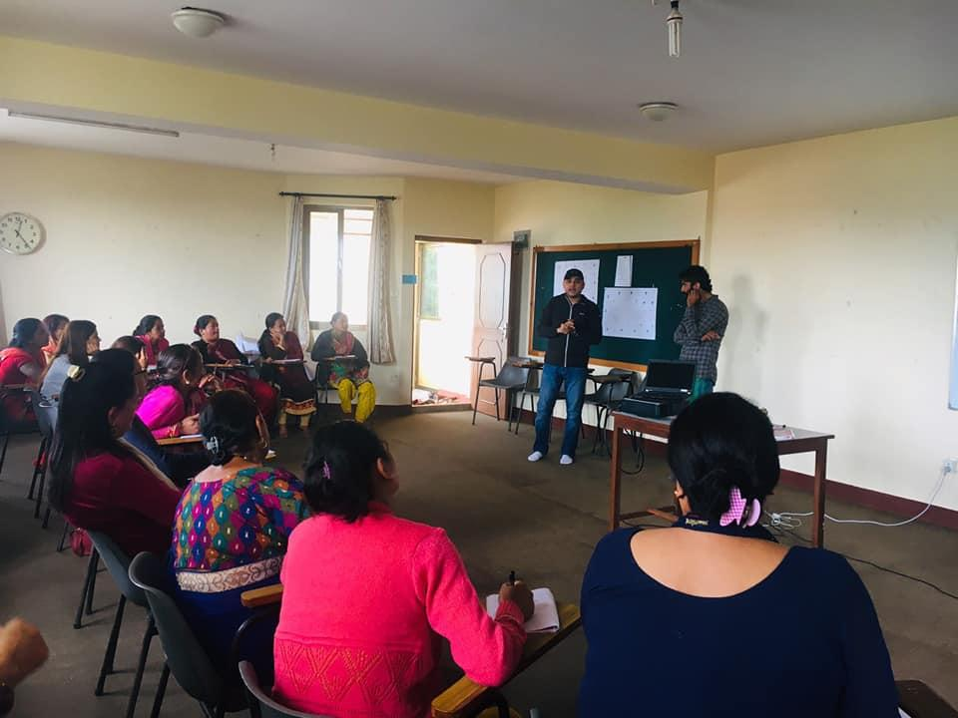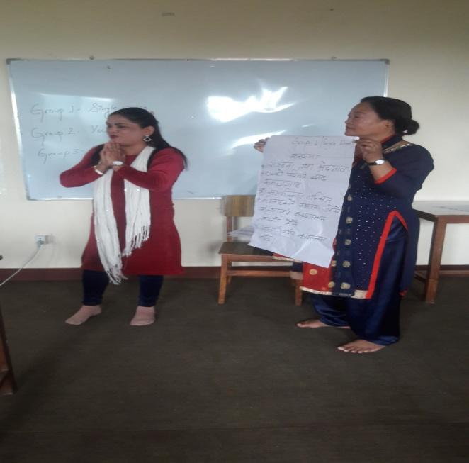**Photos Gallery**

