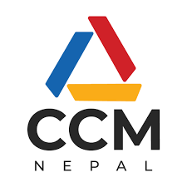
EXPRESSION OF INTEREST
CALL FOR APPLICATIONS UNDER THE GLOBAL FUND TO FIGHT AIDS, TUBERCULOSIS AND MALARIA (GFATM) FOR SHORTLISTING AS NON-GOVERNMENT PRINCIPAL RECIPIENTS
(First published on 14 April 2023)

The Country Coordinating Mechanism (CCM) Nepal invites the qualified and interested agencies to apply for Non-Government Principal Recipients for GFATM grants for HIV and Tuberculosis components for the period of August 2024 to July 2027. The CCM Nepal will determine the amount for each component through an inclusive country dialogue process.
A complete set of Expression of Interest (EOI) documents (Terms of Reference and Attachments) can be obtained free of cost from the CCM Nepal website: https://ccmnepal.org/.
All completed EOI documents are required to be submitted in hard copies to CCM Nepal Secretariat Office at Department of Health Services, Teku, Kathmandu; and submit electronic files in MS Word, Excel, and/or PDF formats to ccmnepaleoi2023@gmail.com. Both submissions must be received No Later Than 5:00 PM (NST), Thursday 4 May 2023.
Please note that this EOI shall remain valid for 90 days after the closing date of the tender (4 May 2023). CCM Nepal will not accept applications after the closing date & time; and shall not be responsible in any form for the incomplete submission of the EOI. CCM Nepal will have all rights to cancel the EOI call without any and prior notice to the applicants.

